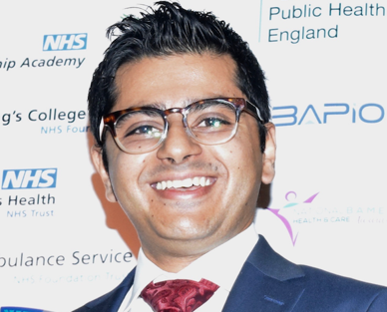

Hi! I’m Muj! I’m a Gastroenterology and Clinical Informatics Trainee at HEE NW and an Honorary Clinical Teaching Fellow in Medical Education within the School of Medical Sciences at the University of Manchester.

We’ve come into this post with many challenges. With the impact of COVID on training, some of us may find it more difficult to navigate the shoals of training – rest assured, we are here to help and to support you. For my IMG friends in training and those hoping to apply, I have an understanding of some of our difficulties, and I will do my utmost to raise them.

I will ask for your help and for your guidance, and with the shared wisdom of my friends Dele and Usman, we will improve the training experience in the North West.

I feel privileged to be appointed your representative and hope to always remain available to help, in whatever way or form I can.

E-mail: Mujtaba.hasnain@gmail.com
Mobile #: 07397005012

