Trafford Public Health Training Prospectus 2025

- Introduction

Trafford is a large metropolitan borough. It makes up one of the 10 authorities that comprise Greater Manchester. It is located in the South West of Greater Manchester.
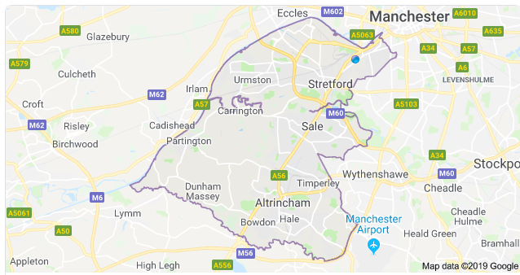

Trafford Town Hall

Trafford as a training location offers a range of exciting professional development opportunities and experiences. The registrar will be based at Trafford Town Hall in Old Trafford where the council and NHS GM Trafford are co-located.

In both health and economic terms, the profile of Trafford is close to that of England as a whole. The population is amongst the healthiest in the North West, but the North West is the least healthy region in the country. One of the greatest challenges in Trafford is the impact of the health and social inequalities which exist in the borough, which are often masked by Trafford’s relatively good health outcomes.

Interactive maps of the borough can be found here: https://www.trafforddatalab.io/ and the Trafford JSNA is available here: http://www.traffordjsna.org.uk/

- The Public Health team in Trafford
Trafford Public Health has recently become a Directorate in its own right within the council in recognition of the cross-cutting work the team undertakes and its contribution to Trafford Council’s 5 corporate priorities:
- the best start for children and young people
- healthy and independent lives for everyone
- a thriving economy and homes for all
- address the climate crises
- culture, sport and heritage for everyone

Our Director of Public Health, Helen Gollins is part of the council’s leadership team.

Leadership of the public health team is led by the Director of Public Health supported by the two Public Health Consultants.

The breadth of our portfolio is managed across a number of sub-teams:
- Health Protection & Infection, Prevention and Control – this team included 4 embedded MFT posts
- Public Health Commissioning, prevention and wellbeing– commissioning of specialist services including primary care and pharmacy services, VCFSE and collaborative commissioning. Thematic leadership across sexual health, substance misuse, alcohol, domestic abuse, tobacco control, children, young people and families
- Wider determinants, screening and immunisation, prevention and wellbeing – addressing the building blocks of health, leading our engagement with the Neighbourhood Programme, assurance of screening and immunisation. Thematic leadership across active travel, physical activity, mental health, suicide prevention, healthy weight, food, climate change, oral health
- Prevention strategy and Fairer Health for Trafford. Thematic leadership across adults, older adults, falls prevention, gambling and violence prevention
- Public Health Intelligence
- Business Support

Additionally we manage and/or feed into a range of corporate/GM programmes including for example Women’s Health, GM infant male circumcision, Migrant Health, Social prescribing and line management of Stockport, Trafford and Tameside’s Child Death Overview Panel Manager

Senior Leadership Team (SLT) is the forum where portfolio leads come together to discuss key issues. Membership is the Director of Public Health, two Consultants in Public Health, Principle Public Health Analyst, three Public Health Programme Managers, Public Health Matron, Public Health Programme Coordinator, and Senior Public Health Registrar. SLT meets weekly and the whole team meets fortnightly. There is an expectation that team members will be in the office a minimum of two days per week, including for face-to-face team meetings

We enjoy strong support from our Lead Member for Health and Social Care and meet monthly to provide public health briefings.

We are a training location for the North West School of Public Health, welcoming Speciality Training Registrars on placement. The DPH is the lead trainer, with both consultants acting as educational supervisors.
We also welcome other professional training placements include GP registrars, Clinical Psychologists and Population Health Fellows. Welcoming trainees supports a culture of continued professional development across the Directorate and helps to keep practice current.

Registrars are able to undertake a wide variety of projects and really get involved with the full remit of Public Health functions.

- Location and transport
The Public Health team is based at Trafford Town Hall, Talbot Road, Stretford, close to the Metrolink tram stops at Old Trafford, Firswood and Trafford Bar.
Trafford Council encourages active travel, and many of the Public Health team are keen cyclists. Showers, lockers and a drying room facility are available at the town hall, as well as secure bike parking and various bike related events throughout the year.
Car parking is also available nearby.

Trafford is on the Manchester to Altrincham tram line so getting to and around the borough via Metrolink is easy. Three motorways, (the M60, M56 and M6) pass through Trafford making it easily accessible.

- Educational Supervisors
Helen Gollins, Consultant in Public Health, is the lead trainer and both Consultants - Kate Shethwood and Claire Robson are education supervisors.

- Academic Links
We have good links with Manchester University who are supporting the evaluation of Trafford’s Neighbourhood Programme.

- Areas of opportunity
Opportunities exist across the breadth of the team’s portfolio for registrars to build and further develop their working knowledge and experience across the core public health competencies spanning health improvement, health protection and healthcare public health. A placement in the team will enable registrars to work in partnership with a wide range of system partners spanning the NHS, Local Authority and VCFSE sectors. Registrars will gain experience of working in a political environment and learn about local authority and wider system governance and scrutiny. There will be opportunities to participate in Trafford’s Health and Wellbeing Board and Locality Board. There will be an opportunity to learn about the importance in public health of providing financial assurance and demonstrating the impact of public health for financial return on investment and health gain. Registrars will experience first hand the challenges and opportunities of aligning public health priorities with those of the wider local authority and NHS ICB and be involved in influencing stakeholders and collaborating to commission, deliver and monitor the impact of programmes designed to improve and protect population health and achieve fairer health for Trafford residents.

- Organisation of Training
Each registrar will agree a work plan based on their learning needs, including outcomes to be achieved. There will be regular meetings between the supervisor and the registrar plus informal contact in-between as needed. Regular informal reviews of the training and progress against the Public Health learning outcomes are undertaken with support to achieve Part A and Part B of the membership exams.

- Examples of StR activity

Examples of previous work undertaken by registrars:

- E-cigarette smoking cessation pilots
- Poverty plan development
- Social Isolation intervention review
- Workplace health leadership
- Public health input into local plan development
- Suicide prevention strategy
- Gram negative bacteraemia review
- Gypsy and Traveller community health needs assessment
- Evidence review of smoking during pregnancy
- Support for the development of a partnership approach to tackling domestic abuse, focussing on perpetrators
- Work with CCG and primary care to increase bowel cancer screening rates in low uptake practices
- Involvement in a health protection recall incident
- Development of a service specification for a community engagement programme
- Community engagement to increase cervical screening uptake in BME women
- Development of a multi-agency Falls Strategy

- Facilities
All registrars will be agile workers and have access to a hot desk, laptop and locker, and are regarded as a full member of the public health team.

- Who to contact
If you are interested in training in Trafford please contact Helen Gollins, Director of Public Health helen.gollins@trafford.gov.uk.

