Recorded Consultation Assessment (RCA)

Objective
A guide for trainers

THE RCA Assessment
A summative assessment of a doctor’s ability to integrate and apply clinical, professional, communication and practical skills
- 13 recorded consultations submitted onto Fourteen Fish. Can be all telephone, all video or all face-to-face consultations – most likely a combination. Allows for trainees working from home

Recording cannot be edited – continuous 12 minute recording, excludes time for consent. Cannot rely on previous videos (GDPR & previous usage for COT assessments). Each video marked by at least one examiner independently

- Tests the same competencies and curriculum areas as the CSA and assessed at the same standard. Assessed in 3 domains (Data Gathering, Clinical Management and Interpersonal Skills) as Clear Pass, Pass, Fail or Clear Fail

- The July and August 2020 sittings did not count towards the maximum 4 attempts but subsequent attempts do – trainee guidance and discussion on appropriate timing to take the exam is advisable

- From November 2020 onwards, it will be mandatory to submit cases from across the GP curriculum that include: a child, an elderly person, a mental health problem and specific clinical problems. See RCGP website: Mandatory Case Selection

- Keep up to date with the RCGP RCA website as new guidance continues to emerge – particularly review the Candidate Handbook, RCA FAQs and policy document (links can be found at the end)

The recording
- Trainee and patient clearly visible where appropriate with good sound quality

- Cases are submitted to the Fourteen Fish Platform and there is a lot of guidance on how to do this on their help pages Fourteen Fish Guidance on Recordings

- If trainees record on platforms other than Fourteen Fish they will need to upload their submission to the Fourteen Fish website. Practices should ensure recordings are handled in accordance with GDPR regulations and care should be taken to ensure this is maintained including systems for data transfer during any upload process

- Supervisors will need to authenticate the recordings for final submission by verifying that the recording is between the trainee and a patient, on the Fourteen Fish platform

- Trainees can share their Fourteen Fish videos with you to watch. You will be able to annotate this with comments if you wish

- Suggest trainees only share videos with you that they have already watched and through their self-assessment have identified as their best or if they would like guidance on recurrent problem areas in the consultation

- All recording needs patient consent (before and after) – refer trainees to the RCA Consent document for guidance: Guidance on consent

Be aware of RCGP guidance on breaches in exam regulations:

- One of the cases has not met the mandatory case selection criteria selected by the trainee and no other consultation was deemed to have done this – Zero Marks
- If 2 cases have not met the mandatory case selection criteria as above – Whole Submission Rejected
- A consultation in which clothing equivalent to the ‘swimsuit area’ is removed and captured on a visual recording must not be submitted for assessment – Zero Marks
- Case with a pause in the recording – Zero Marks
- If there are 2 breaches then the whole submission will be rejected
Where in doubt conduct all physical examinations off camera ensuring that dialogue can be clearly heard.

Other FAQs concerning mandatory cases (please note these FAQ are not official RCGP FAQ but derived from our training community):
Does a 2 week rule referral count as a mandatory ‘urgent’ case? YES
Can one case tick more than one of the mandatory criteria? YES

PLEASE CHECK the RCGP RCA FAQ on a regular basis in case of updates

Trainee preparation
- Trainees can build up a library of cases on Fourteen Fish and select 13 cases to submit

- Consider the types of consultation individual trainees are doing (video/telephone/face-to-face) and any limitations of consulting method in ensuring appropriate case exposure

- Consider mechanism of working within the surgery such as pre-triage or electronic navigation prior to a consultation - ensure this isn’t detrimental to the trainee’s consultation and utilise these systems to ensure appropriate case exposure e.g. the trainee can be directed to more complex consultations or certain types by vetting information

- Trainee areas of reduced knowledge should be identified and addressed. The Fourteen Fish CSA and AKT packages are accessible for all trainees throughout their training. Identify any gaps relating to any of the mandatory cases early e.g. Women’s health.

- Problems new to the trainee rather than follow-ups more likely to be appropriate for submission
- Consider trainee wellbeing – health, personal or practice issues. Signpost for support to their Training Programme Director, Associate Dean and Lead Employer where needed
- Consider addressing any issues with your trainee’s organizational skills in preparation for the exam and ensuring a detailed understanding of the assessment – there is a lot of information on the RCGP website and the trainee needs to take time to read and digest this

Consider recurrent consultation skills problems and address these - select themes for intervention to help to maximise improvement e.g. consulting like a hospital doctor and failing to identify patient specific information in order to share management options.
- Remember that the examiner can’t see the patient’s medical record so all relevant important aspects need to be verbalized e.g. allergies, medication, past medical history

- The consultation needs to be fluent, natural and true – consultations should be in keeping with the current situation in light of the covid pandemic and appropriate for the method of consulting. Examiners are all GPs and familiar with the current situation with respect to GP consultations

- Ensure that multiple patient problems are all appropriately handled. In particular if 2 problems are presented, has the trainee managed to focus on the more important one for most of the 12 minutes? If there are two problems each taking up 6 minutes, this is not a suitable consultation.

- Examiners need to see evidence of a competence to give appropriate credit for it when marking. Low complexity cases offer limited opportunities to display relevant capabilities and marking will reflect that. This will inevitably penalise candidates submitting large numbers of these cases

A consultation in which clothing equivalent to the ‘swimsuit area’, is removed and captured on a visual recording must not be submitted for assessment. (see exam breaches above)
WARNING: Unlike the CSA, where each station is a standardised role played case, the RCA station is selected by trainees. The main risk is one of INSUFFICIENT EVIDENCE, forcing the examiner to fail the case in one or more domains. A wide, diverse case submission is most likely to present sufficient evidence. Help the trainee to ensure there is sufficient challenge in cases – think would this case be best seen by a GP and does it provide sufficient evidence that the trainee is a capable GP. Note the ‘fail’ grade descriptors:

- ‘There is no evidence or very limited evidence provided to demonstrate capability of a doctor sufficient for safe independent UK General Practice in this domain.’
The RCGP has a link to describe insufficient evidence/low challenge cases: Details on low challenge/insufficient evidence cases

PRACTICE SUPPORT MECHANISMS TO SUPPORT THE TRAINEE

- The trainee needs to have the recording technology functioning well and be efficient in their use of this. Ensure a failure of technological processes does not interfere with the RCA submission quality.
- Ensure good sound quality. Consider a ‘do not disturb sign’ on the door and ensure colleagues do not disturb the trainee with telephone calls or screen messages
- Video and face to face consultations should show the trainee and patient’s face if possible
- For telephone consultation recordings via digital platforms inform patients that the area code might not be local to avoid them thinking it is a hoax call
- Consider the practice procedures for directing cases to trainees – are they pre-triaged/directed by a care navigator – consider how the practice system be used to the best advantage for the trainee accessing the most appropriate cases.
- Consider if clinical colleagues in the practice can be made aware of the right kinds of cases for the trainee and help trainees to access these
- If possible consider only willing or consenting patients for recording to be directed to the trainee
- Consider trainee appointment length – long enough for recording and the right balance of case exposure for that trainee
- Some trainees might benefit from a stop-clock to help with time management issues. Others may benefit from crib sheets providing these aren’t detrimental to interpersonal skills

Analysis of Consultations
The RCGP have published a marking scheme that will be used to mark the consultation:

- Data Gathering, Technical and Assessment Skills

- Takes a focussed history to allow for a safe assessment to take place
- Elicits and develops relevant new information
- Rules in or out serious or significant disease
- Considers and/or generates any appropriate diagnostic hypotheses
- Explores where appropriate the impact and psychosocial context of the presenting problem
- Plans, explains and where possible, performs appropriate physical/mental examinations and tests
- Appears to recognise the issues or priorities in the consultation

- Decision Making and Clinical Management Skills

- Appears to make a safe and appropriate working diagnosis/es
- Offers appropriate and safe management options for the presenting problem
- Where possible, makes evidence-based decisions re prescribing, referral and co-ordinating care with other health care professionals
- Makes appropriate use of time and resources whilst attending to risks
- Provides realistic safety netting and follow up instructions appropriate to the nature of the consultation

- Interpersonal Skills

- Encourages the patient's contribution, identifying and responding to cues appropriate to the consultation
- Explores where appropriate, patient’s agenda, health beliefs & preferences
- Offers the opportunity to be involved in significant management decisions reaching a shared understanding
- When undertaken, explains and conducts examinations with sensitivity and obtains valid consent
- Provides explanations that are relevant, necessary and understandable to the patient

Ensure that all 3 domains can be assessed and there is sufficient evidence in all 3 domains within the 12 minute time frame.

Closely aligned with the Consultation Tool(Red/Amber/Green) and resources written by RCA examiners on our NW Consultation Toolkit site @ Fourteen Fish. Video introduction to the toolkit

Utilise the North West Consultation Toolkit on Fourteen Fish
You can download the information from the site via PDFs for trainees, including all of the reflective exercises and educational activities to help them develop their consultation skills. Keep these in a folder on your desktop. The trainees can access these through the RCA Plus Package.

RCA REVISED FEEDBACK STATEMENTS
The RCGP have improved the feedback statements and also added various suggested educational strategies for each one. All of the strategies align closely with educational strategies found @ NW Consultation Toolkit
RCA Guidance on Utilisation of Feedback Statements

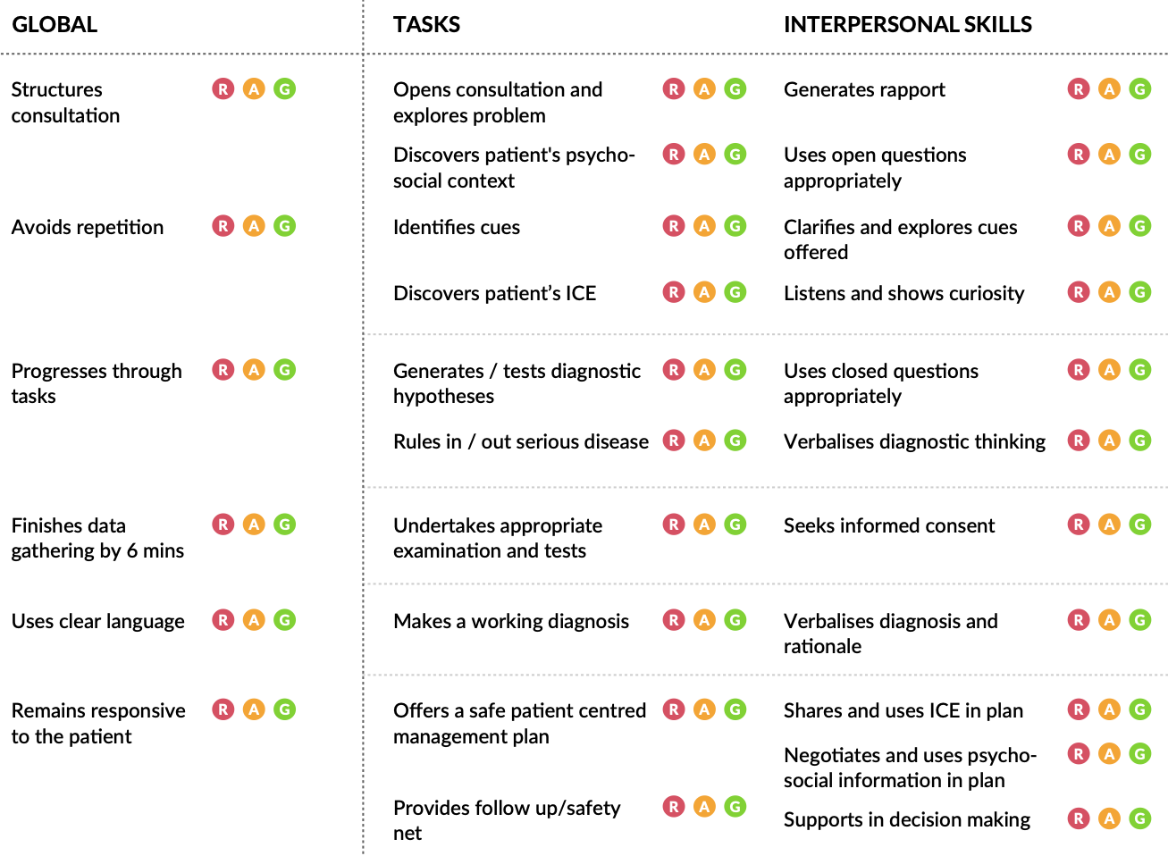
© Copyright 2018 Anne Hawkridge and David Molyneux HEENW

Consultation Tool. PDF version can be downloaded from NW England Consultation Toolkit site
Can RAG circle/use the interactive version to rate – the trainer can help them to become better at self-assessing their own consultations.
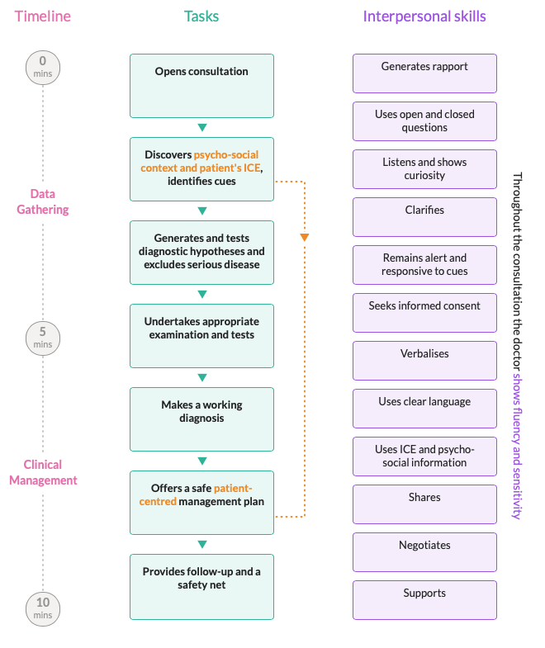
© Copyright 2018 Anne Hawkridge and David Molyneux HEENW

Consultation Overview
- The trainee has ownership of their submission with the trainer and educator for support and guidance. Encourage use of the resources.
- The trainee needs to ensure they are appropriately analyzing their videos – to become their own RCA examiner, in order to select appropriate cases for submission
- The selection for submission is theirs - do not tell them a video will pass – support them in how to self-assess so they make the ultimate judgement!
- Use formative not summative feedback

helping your trainee to decide when to take the RCA

- Remember that July and August RCA sittings were in exceptional times and additional to the maximum 4 exam attempts, but future sittings will now count
- In general trainee guidance is to take the exam a maximum of 2 attempts in their ST3 year, leaving a further 2 sittings for any extension period. It is important that RCA re-takes are not submitted before a trainee has progressed in the areas of poor performance.
- Consider a holistic approach to exam timing – consider what is going on in the trainee’s life with the range of external factors that might impact on their exam preparation
- Consider if they might benefit from Health and Wellbeing support or a discussion with the training programme director/educator team
- There is a section on the RCGP website that allows trainees to apply for special exam adjustments if appropriate

SOX programme and utilising SOX themes locally

- Central SOX support was offered to all trainees taking the RCA in the exceptional circumstances period of July and August 2020
- Central SOX support for future sittings will be offered to trainees after every RCA fail
- Trainer groups in some areas are setting up a local system of SOX support for trainees before their first RCA attempt with trainers buddying up to arrange a single triadic tutorial for each ST3 (Trainer A joins the trainee and their trainer B for their tutorial one week on Microsoft Teams and another week there is similar swap where Trainer B joins trainer A and their trainee)
- Local SOX might be helped by:
  - a RCA trainee questionnaire (see separate attachment) that helps the second trainer to get to know the trainee quickly
  - discussion with the trainer to find out the areas of difficulty as they see them and where the second trainer can best help (sometime just reiterating trainer identified points can be of great help and support to the trainer)
  - viewing a consultation that the trainer and trainee want an opinion on, as a fresh pair of eyes, to help with calibration and identifying main themes where the trainee needs to do further work, developing a strategy with them

Useful Links to RCA resources

RCA Assessment Policy
RCA FAQs
Mandatory Case Selection Criteria
Educator top tips
Guidance on avoiding low challenge cases
Guidance on consent
MRCGP exam regulations
Fourteen Fish Guidance on Recordings

