Recorded Consultation Assessment (RCA)

Objective
A guide for trainees

THE RCA Assessment
The Recorded Consultation Assessment (RCA) might seem like a daunting (and expensive!) prospect but preparing well, listening to the right advice, aiming high and above all maintaining a positive approach will ensure your success.

A General Practitioner encounters countless presentations and you will see your supervisors expertly navigate their way through a range of medical, psychological, social and practical issues, whilst ensuring a tailored, individualised consultation to meet the needs of each patient.

The RCA is a component of the MRCGP that gives evidence that you are ready to be an independent General Practitioner.

Knowledge of the requirements of the exam will help you to understand how you can maximise day-to-day learning opportunities, as you will quickly realise that every patient interaction you experience, is the best preparatory material.

understand the exam structure and requirements early

The RCA is a summative assessment of a doctor’s ability to integrate and apply clinical, professional, communication and practical skills:
- 13 recorded consultations submitted onto Fourteen Fish. Can be all telephone, all video or all face-to-face consultations – most likely a combination. Allows for trainees working from home

- Recording cannot be edited – continuous 12 minute recording, excludes time for consent. Cannot rely on previous videos (GDPR & previous usage for COT assessments). Each video marked by at least one examiner independently

- Assessed in 3 domains (Data Gathering, Clinical Management and Interpersonal Skills) as Clear Pass, Pass, Fail or Clear Fail

- There are mandatory criteria to include in your submission including cases from across the GP curriculum that include: a child, an elderly person, a mental health problem and specific clinical problems. See RCGP website: RCA mandatory cases

- Keep up to date with the RCGP RCA website as new guidance continues to emerge

The recording
- Doctor and patient clearly visible where appropriate with good sound quality

- Cases are submitted to the Fourteen Fish Platform and there is a lot of guidance on how to do this on their help pages Fourteen Fish Guidance on Recordings

- If you record on platforms other than Fourteen Fish you will need to upload your submission to the Fourteen Fish website. Handle recordings in accordance with GDPR regulations and take care to maintain this with any data transfer during an upload process

- You can download the Fourteen Fish Consult App from the App store and this will allow you to record without the need of credits

- Supervisors will need to authenticate the recordings for final submission by verifying that the recording is between you and a patient on the Fourteen Fish platform

- You can share your Fourteen Fish videos with your supervisor who will be able to annotate these with comments if they wish

- Consider prioritising videos for supervisor sharing that you have watched and self-assessed as your better consultations or those that you realise you need guidance on as you are having recurrent problems with certain aspects of the consultation

- All recordings needs patient consent (before and after) – see RCA Consent document for guidance: Guidance on consent

preparation

Now you understand the challenge, you will realise that you need to commence your RCA preparation as soon as possible, but don’t panic! The majority of candidates will pass the RCA on their first attempt and there are plenty of experts and resources to guide your preparation

- You can build up a library of cases on Fourteen Fish or other recording modality and select 13 cases to submit
- Consider the types of consultation you are doing (video/telephone/face-to-face) and any limitations of consulting method in ensuring appropriate case exposure
- Determine individual ways around problems eg PPE affecting rapport in a consultation
- Consider mechanism of working within your surgery such as pre-triage or electronic navigation prior to a consultation - utilise your system to better ensure appropriate case exposure eg. systems might allow you to improve access to the right kinds of cases
- Self-assess and identify and address knowledge gaps
- Problems new to you rather than follow-ups more likely to be appropriate for submission
- Consider your appointment length to ensure adequate time for the video and consent but sufficient case numbers to ensure opportunity for a good submission spectrum
- Consider your own wellbeing – health, personal or practice issues. Access support from your Supervisor, Training Programme Director, Associate Dean or Lead Employer where needed
- Ensure you have a detailed understanding of the assessment – there is a lot of information on the RCGP website and you need to take time to read and digest this
- Analyse and identify recurrent consultation skills problems and address these as a matter of urgency – subscribe to the RCA Plus package on FourteenFish to use the Consultation Tool working with your trainer to analyse and plan educational strategies to change behaviours. All ST3s can claim reimbursement of the RCA Plus cost through Study Leave budgets.
- Prioritise key consultation tasks and skills as summarized in the Consultation tookit
- Remember that the examiner can’t see the patient’s medical record so verbalise all relevant patient information for example, allergies, medication, past medical history
- Care with submitting consultations where more than 1 problem is presented by the patient, for example ear wax and rectal bleeding. You may struggle to cover both well in the 10 minutes time limit. You must also avoid spending excess time on the less important one, in this case the ear wax.
- Care with physical examination cases ‘A consultation in which clothing equivalent to the ‘swimsuit area’, is removed and can be seen on a visual recording must not be submitted for assessment. If a consultation is submitted, where this guidance is breached, no marks will be awarded for that consultation.’ RCGP website (see detailed guidance and video on this)
WARNING: In the RCA you select the cases for submission yourself. A big risk is one of INSUFFICIENT EVIDENCE, forcing the examiner to fail the case in one or more domains. A wide, diverse case submission is most likely to present sufficient evidence. Ensure there is sufficient challenge in cases – think, would this case be best seen by a GP and does it provide sufficient evidence that you are a capable GP.
Note the ‘Clear Fail’ grade descriptor:
- ‘There is no evidence or very limited evidence provided to demonstrate capability of a doctor sufficient for safe independent UK General Practice in this domain.’
The RCGP has a link to describe insufficient evidence/low challenge cases: Details on low challenge/insufficient evidence cases

GP PRACTICE systems to support you
- Master the recording technology! Avoid a situation where a great consultation can’t be submitted due to failure of technological processes
- Ensure good sound quality. Consider a ‘do not disturb sign’ on the door and on your telephone. Ask for a bar on screen messages during recording periods.
- Video and face to face consultations should show your face and patient’s face if possible
- For telephone consultation recordings via digital platforms, consider informing patients that the area code might not be local, to avoid the risk of thinking they are being contacted by a hoax caller
- Discuss with your trainer, the practice procedures for allocating cases to you – are they pre-triaged/directed by a care navigator? How can the practice system be used to the best advantage to allow you to access the most appropriate cases?
- Ask if clinical colleagues could be made aware of the right types and variety of cases that would work for this assessment and if they can help to direct these to you eg if a nurse comes across a blood test showing a patient is a new diabetic
- Ask if only willing or consenting patients for recording can to be directed to you and review your appointment length – long enough for recording and the right balance of case exposure appropriate for your consulting
- Other suggestions might be a clock on your desk to help awareness of time management issues and a copy of the Consultation Overview to remind you of the structure of an effective consultation.

The GP Consultation
You need to offer the evidence to reach the standard ‘Fit for independent practice in UK General Practice’.
We know from existing successful CSA support offered in the North West, that you must start with mastering how you consult. You need to consult ‘like a GP’ and not as a hospital doctor.
We also know that you must have sufficient GP knowledge and know how to apply this to each patient, both to reach a diagnosis and to offer safe management plans.
The resources in the NW England Consultation Toolkit (accessed via the RCA Plus package on FourteenFish) will help you to analyse where your consulting is up to and how to develop weak areas and also offer strategies for improving your knowledge

Practice consultation skills
Practice is key, but take care not to reinforce consulting ‘like a hospital doctor’. You must change the way you consult as a priority, the first step is to understand the key tasks and skills required to consult like a GP.

Encourage feedback
You should actively seek feedback from patients and colleagues and use their advice to develop your consultation. Using the Consultation Overview and Consultation Tool to self-assess is a good starting point.

Patient Unmet Need and Doctor Educational Need
Remember that day-to-day, in whatever post you are doing, you will come across PUNs and DENs (Patient Unmet Need and Doctor Educational Need) – never leave these. Whenever you realise a gap in your knowledge and understanding, address it quickly – don’t leave it or you will forget about it and the next time you encounter it might be in a case that would be ideal for the RCA! Use the Fourteen Fish RCA Plus package and AKT package as excellent resources of up to date videos on over 50 topics. You have free access to this (reimbursed through study leave).

Video your consultations
Get into the habit of videoing at least one of your surgeries every week (your supervisor will show you the procedure for this). Take time to watch the consultations you have videoed and analyse yourself and the patient’s reaction to you. Use the Consultation Overview and Consultation Tool for more detail. Consider alternative and better ways of consulting (you can check the North West England Consultation Toolkit for a variety of different methods) and try these out day-to-day.

Reflect on each consultation
Reflect after every consultation and consider how you might improve. This will allow you to make progress and you will soon realise that every patient is different - you need to have lots of tools in your armoury to adapt your consultation for each one of them, whilst maintaining a professional approach.

Analysis of Consultations
The RCGP have published a marking scheme that will be used to mark the consultation:
- Data Gathering, Technical and Assessment Skills

- Takes a focussed history to allow for a safe assessment to take place
- Elicits and develops relevant new information
- Rules in or out serious or significant disease
- Considers and/or generates any appropriate diagnostic hypotheses
- Explores where appropriate the impact and psychosocial context of the presenting problem
- Plans, explains and where possible, performs appropriate physical/mental examinations and tests
- Appears to recognise the issues or priorities in the consultation

- Decision Making and Clinical Management Skills

- Appears to make a safe and appropriate working diagnosis/es
- Offers appropriate and safe management options for the presenting problem
- Where possible, makes evidence-based decisions re prescribing, referral and co-ordinating care with other health care professionals
- Makes appropriate use of time and resources whilst attending to risks
- Provides safety netting and follow up instructions appropriate to the nature of the consultation

- Interpersonal Skills

- Encourages the patient's contribution, identifying and responding to cues appropriate to the consultation
- Explores where appropriate, patient’s agenda, health beliefs & preferences
- Offers the opportunity to be involved in significant management decisions reaching a shared understanding
- When undertaken, explains and conducts examinations with sensitivity and obtains valid consent
- Provides explanations that are relevant, necessary and understandable to the patient

Ensure that all 3 domains can be assessed and there is sufficient evidence in all 3 domains within the 12 minute time frame.
The RCGP marking scheme is closely mapped to the Consultation Tool (Red/Amber/Green) and resources written by RCA examiners on our North West England Consultation Toolkit site on Fourteen Fish.

Learning how to accurately self-analyse your own consultation – become your own RCA examiner!
North West Fourteen Fish Preparation Resources
You have free access (reimbursed through study leave) to two preparation packages as you are a HEENW Trainee (these packages otherwise incur a cost)
1) ‘Pass the AKT’ where the Clinical topic Revision Library is hosted
2) ‘RCA Plus’ contains lots of useful examiner tips and a wealth of videos to watch to support your preparation along with the North West Consultation Toolkit
This was written by North West RCA examiners and contains a model Consultation Overview of the components of a good RCA consultation. If you are struggling with a particular aspect of the consultation there are lots of linked recommended educational exercises. You should make use of it with your trainer when you are in your GP posts
You or your trainer can also download the information from the North West England Consultation Toolkit site via PDFs if they think this would be helpful to you, including suggested reflective exercises and educational activities to help you to develop your consultation skills.

Guide to the North West Consultation Toolkit

Using the toolkit: an example

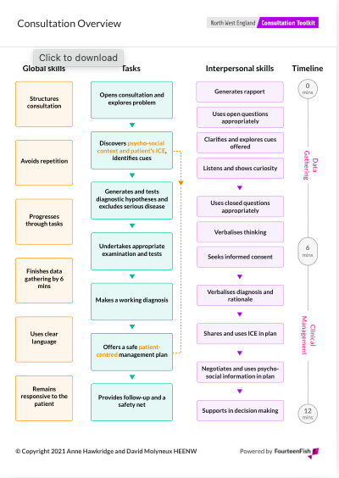

Consultation tool
This is detailed and closely aligned with the RCA marking schedule. It can be downloaded from the North West Consultation Toolkit site as a PDF version or be used electronically, allowing your trainer and you to share.
You and your supervisor can highlight a RAG circle to assess your own videos – it is important to become better at self-assessing your own consultations. You need to become your own RCA examiner!

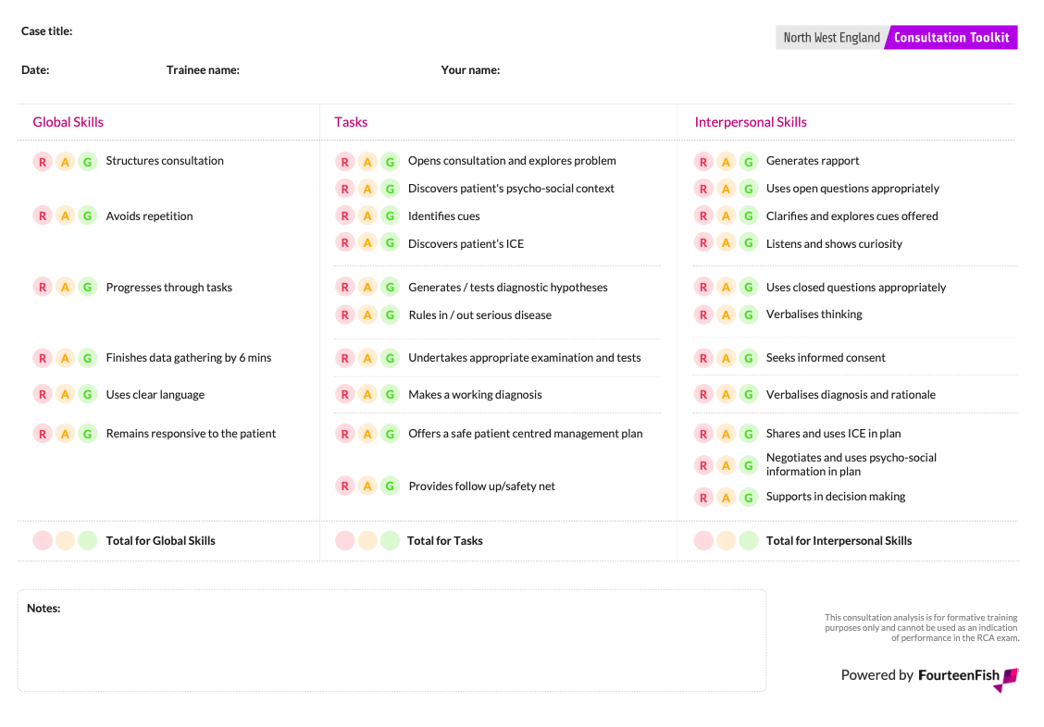
© Copyright 2021 Anne Hawkridge and David Molyneux HEENW

The selection for submission is yours – your trainer is not there to tell you a video will pass – you need to be able to accurately self-assess and make that ultimate judgement on which cases to submit.

maximise Learning from your GP supervisors in RCA preparation
Your Educational Supervisor and Clinical Supervisor in your GP posts are invaluable to support your RCA preparation
Your supervisors have experience and specific training in guiding you to pass your RCA exam.
Encourage them to give you feedback and welcome any constructive advice on where you need to improve. Ask them questions, discuss cases you’ve seen and make the most of their expertise and advice. If you aren’t told where your weaknesses are, you must ask, as you need to be constantly finding ways of improving.

Individualise your educational experience for maximum benefit
Discuss the case-mix you are seeing in your day-to-day practice and consider if there are any areas you are missing out on, so that your practice can help to adjust this. Optimise your appointment length through discussion with your supervisor, to ensure sufficient and appropriate challenge regarding your time management and exposure to a good variety of patient presentations.

AKT and WPBA in preparation for the RCA
Use your e-portfolio to guide your RCA preparation. Create learning log entries on your consulting skills and reflect on how you are going to ensure you do better. Look at the comments your supervisors write on your learning logs and in your COT and CBD assessments. Take heed of your PSQ and MSF outcomes, using these to consider how you might improve your consultation.
Remember the components of the MRCGP are not mutually exclusive, but the AKT and WPBA very much complement the RCA

GP Structured teaching programme in RCA preparation
The teaching sessions organised by your local programme are all useful towards RCA preparation but you will find that there are many sessions organised specifically for this purpose. Programmes will often organise sessions where you can receive clear feedback from experienced educators.
This complements the work you are doing in your practice with your supervisor and allows you to benchmark yourself against your peers.

RCA Preparation Courses
Your structured teaching programme and tutorial time with your supervisor is the best guide for RCA preparation. You will hear of many commercially run courses but these will often offer conflicting advice and contrary to expectation, be detrimental to your preparation.

RCA mentors
Another useful resource on your programme are trainees ahead of you, who might have taken the exam. Your programme can put you in contact with trainees who have achieved success in the RCA and this might be helpful to you.

Breaches in Exam Regulations
Ensure you are familiar with the exam regulations and note:

- If a case you submit does not meet the mandatory case selection criteria you have linked it to (or you omit to submit one of the mandatory case selection criteria) and there is no other case you have submitted that does, you will be awarded no marks for that consultation
- If 2 cases you submit do not meet the mandatory case selection criteria your whole submission will be rejected
- If a case does not comply with the ‘swimsuit’ test for intimate examinations, you will be awarded no marks for that consultation
- If a case is not a continuous recording, you will be awarded no marks for that consultation
- If there are two or more breaches your whole submission will be declined

Do keep up to date with the RCGP RCA website as information about the exam is emerging all of the time

deciding when to take the RCA
Do not book an exam sitting before full discussion and agreement on the most appropriate time with your Educational Supervisor.
Do not feel pressured into taking the exam when other trainees you know are taking it – everyone is an individual and the appropriateness of exam timing needs to be individualised.

Timing is important
Exam preparation can be influenced not only by your own rate of progress and development but lots of external pressures such as responsibilities at home or health issues.
Do involve your Educational Supervisor and Training Programme Director in understanding all the influences on your ability to prepare for exams as they will be able to help with ensuring appropriate support and guide your readiness to sit. If appropriate, refer to the area about ‘special adjustments’ on the RCGP RCA section of the website and complete your application as indicated.

- Remember that July and August 2020 RCA sittings were in exceptional times and additional to the maximum 4 exam attempts, but future sittings will now count
- In general guidance is to take the exam a maximum of 2 attempts in your ST3 year, leaving a further 2 sittings for any extension period – really to space sittings and allow time for progression

Useful Links to RCA resources

RCA Assessment Policy
RCA mandatory cases
Details on low challenge/insufficient evidence cases
RCA FAQs
Educator top tips
Guidance on avoiding low challenge cases
Guidance on consent
Fourteen Fish Guidance on Recordings
Guide to the North West Consultation Toolkit
Using the toolkit: an example

Success is the beginning!
Remember when you pass this exam you are in a great position to be commencing a career in General Practice but the learning and reflection you will have demonstrated to achieve success, is part of a career long process as a General Practitioner.

