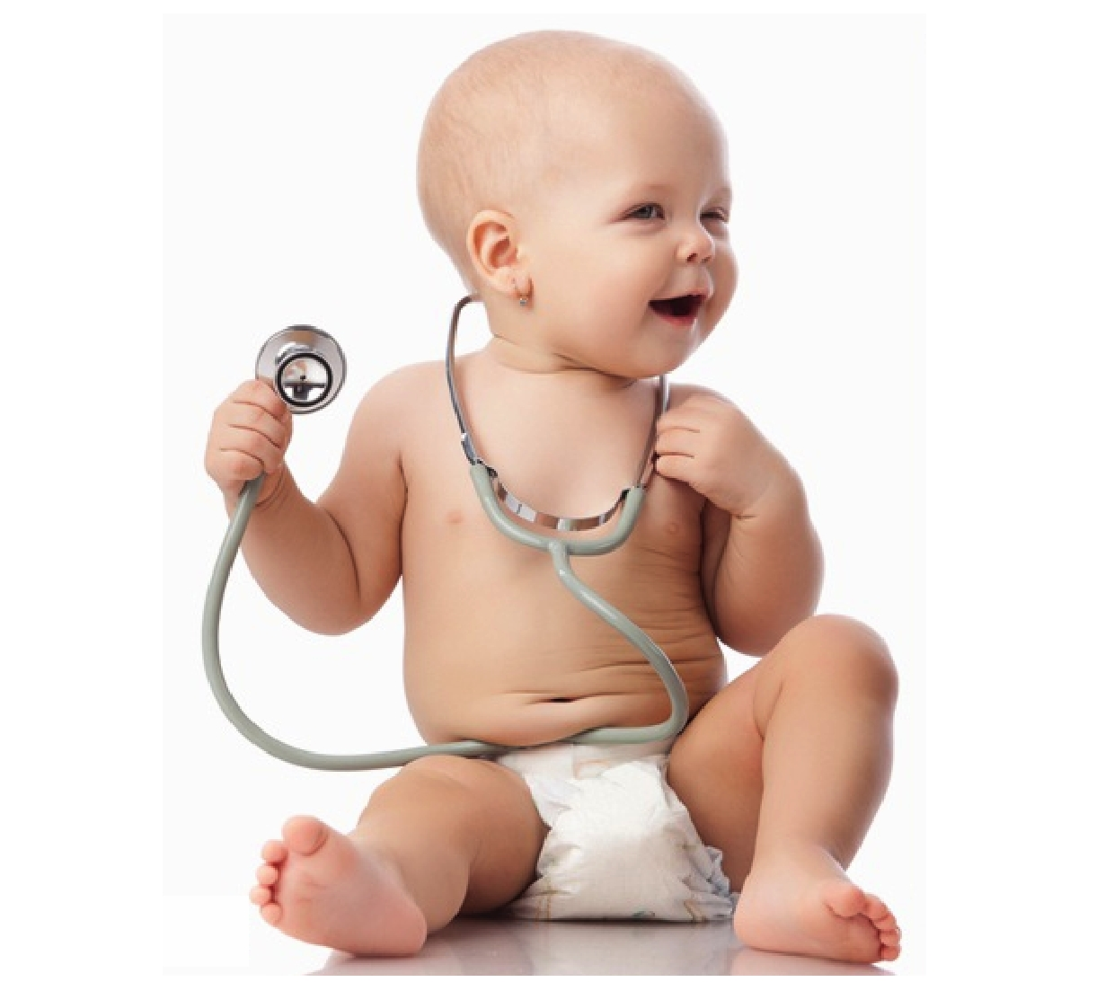
North Western School of Paediatrics Trainee Guide
Author: Dr Constantinos Kanaris
Edited and updated by: Dr Anna McNamara
Table of Contents

Contents………………………………………………………………………………………………………………………..…………2

Welcome…………………………………………………………………………………………………………………….………..3-4

Base Hospitals……………………………………………………………………………………………………………..….…….…5

Training opportunities………………………………………………………………………………………………………….…..6

Whos' who?……………………………………………………………………………………………………………………………..7

Training………………………………………………………………………………………………………………………………..8-9

Study leave and expenses…………………………………………………………………………………………....……10-12

Travel Expenses……………………………………………………………………………………………………………...…13-14

Research and time out of programme (OOP)……………………………………………………………..……15-17

Conferences…………………………………………………………………………………………………………………………..18

Manchester Paediatric Club…………………………………………………………………………………………….......19

Assessment and supervision………………………………………………………………………………………………19-20

Other forms of Support………………………………………………………………………………………………………..….21

Welcome to the Paediatric Training Guide for the North Western School of Paediatrics at Health Education North West!

The purpose of this handbook is to give you essential information needed for effective training in the North West. There is also an abundance of information readily available online via the Royal College of Paediatrics and Child Health.

The North West has the perfect balance of urban and rural settings; from the view point of hospital placements and also lifestyle.

You will have the opportunity to work in busy teaching hospitals, benefit from the proximity of medical schools and supra-regional specialist units, while having the option to live amongst the buzz of a city centre or in the peace and tranquility of the countryside.

As a region we have always been at the forefront of Postgraduate Education. Much of the
framework for supervision, training and assessment was indeed developed by paediatric training units within the region. As a result there is a well-established system of excellent supervision and training. We are always working to put the teaching of trainees both in and outside of the clinical settings at the top of the priorities list.

Introduction
This guide has been created as an aid to both existing and potential paediatric trainees as well as trainers. Paediatric training has evolved considerably over the past few years and improvements are constantly being made.

This document aims to provide information on the structure of the Paediatric training programme in Health Education North West (HENW) - previously, the North Western Deanery). Whether you are considering training in Paediatrics or you’re already a trainee, you should find information here about the outstanding training and opportunities within the region, both within a clinical and a research setting.

This guide is not an exhaustive source of information on your targeted training needs, it simply covers the basic aspects of training in or around the Greater Manchester area. It may also be useful to get further information by discussing the training programme with either an existing trainee or your educational supervisor.

Further information can be obtained by contacting the training programme directors (See
below). Alternatively, every hospital with a paediatric department will have an RCPCH tutor. This is a paediatric consultant who is specifically responsible for that hospital's paediatric educational delivery. The paediatric college tutor usually has links to both the RCPCH and the School of Paediatrics.

Base Hospitals

Bolton Royal Hospital
Neonates (level 3)
General Paediatrics
Neurodisability

Blackpool Hospital
Neonates
General Paediatrics
Community

Burnley General Hospital
Neonates (level 3)

Bury
Community

Lancaster
General Paediatrics
Community (Lancaster & Kendal)

North Manchester General Hospital
General Paediatrics
Neonates
Infectious Diseases

Oldham Royal Hospital
Neonates (level 3)
General Paediatrics

Preston
Tertiary Neonates
General Paediatrics
Neurology Neurodisability

Rochdale Royal Infirmary
Community Paediatrics

Royal Manchester Children's Hospital
Endocrinology
Emergency Paeds
Gastroenterology
General Paediatrics
Hematology/Oncology
HDU
Allergy & Immunology
Metabolic
Nephrology
Neurology
PICU (ST5+)
Respiratory Cardiology
Rheumatology

Royal Blackburn Hospital
General Paediatrics
Community
Neurodisability

Salford Royal Hospital
Community

Stepping Hill
Neonates
General Paediatrics

St. Mary's Hospital
Neonates (level 3)

Tameside Hospital
Neonates
General Paediatrics

Wigan
Neonates
General Paediatrics
Community

Wythenshawe
Neonates
General Paediatrics and community
Training Opportunities

Allergy & Immunology*
Cardiology
Community Paediatrics*
Emergency Paediatrics
Endocrinology *
Gastroenterology*
General Paediatrics
Genetics
Haematology *
Metabolic *
Neonatal Intensive Care *
Nephrology *
Neurodisability *
Neurology *
Oncology *
Paediatric Intensive Care* and Critical Care Transfers (NWTS)*
Respiratory *
Rheumatology*

* National Grid Training offered
Position | Name | Contact
Postgraduate Associate Dean | Simon Carley | Simon.Carley@cmft.nhs.uk
Head of School (joint Mersey) | Colin Morgan | Colin.Morgan@lwh.nhs.uk
ST1 – ST3 Training Programme Director | Ruth Gottstein | Ruth.Gottstein@cmft.nhs.uk
ST4+ Training Programme Director | Guy Makin | Guy.Makin@nwpgmd.nhs.uk
Regional Advisor – career Lead | Suparna Dasgupta | Suparna.Dasgupta@pat.nhs.uk
Deputy Regional Advisor | Sunil Bagewadi | Sunil.Bagewadi@pat.nhs.uk
RCPCH Academic Advisor | Peter Arkwright | Peter.Arkwright@cmft.nhs.uk
LTFT Training Lead and Careers Lead | Alison Jobling | Alison.Jobling@stockport.nhs.uk
LTFT Training Lead – Deputy | Mo Chi-Ning | Chi-Ning.Mo@elht.nhs.uk
RCPCH Trainee Representative | Anna McNamara | annamcnamara@doctors.org.uk  paedsnorthwest@gmail.com
Trainee Social Media Officer | Emily Wilby | Emily.Wilby@doctors.org.uk
Speciality School Manager | Emma Woods | emma.woods@nw.hee.nhs.uk
School Administrator | Michele Turner Holmes | michele.turner-holmes@nw.hee.nhs.uk
Manchester Paediatric Club Rep | Thanos Konstantinidis | thakonsta@doctors.org.uk

Training

Level 1 Training STI-ST3

The first 3 years of training offer the general and tertiary paediatric on calls, focusing on history taking, core paediatric knowledge and clinical skills.

As trainees progress through the first three years they are expected to pass their exams. There are protected training days as part of the Specialty Trainee Educational Program (STEP) based at RMCH (unless otherwise noted) which takes places on 3rd & 4th Wednesdays of each month. Emails are sent to trainees with further details about this. There is exemption in the first 6months of ST1 when you will be having paed teaching locally and during the tertiary neonatal placement, although you are welcome to attend if the rota permits. The 12months cycle so topics are covered again. On call commitments supersede this, and a 75% of topics must be covered is expected for satisfactory progression.
During ST1-2 trainees undergo a minimum of 12 months of general paediatrics (or 9 months general paediatrics and 3 months’ secondary neonates), 6 months of tertiary neonates and 6 months of a tertiary paediatric specialty, usually at RMCH.

ST3 is then divided in 6 months at middle grade level, usually in a DGH, and 6 months in a tertiary specialty usually at RMCH on the junior grade rota. Completion of the MRCPCH clinical is expected by the end of ST3 to allow trainees to advance to the next level of training. In addition to informal "in house" training, trainees that have passed the first three parts of MRCPCH (FOP, TAS and AKP) and have a confirmed place for the clinical exam are offered an intensive clinical revision course. This usually takes place over two days in the form of a mock clinical examination and has been highly praised from previous trainees. Please inform Dr Shaila Sukthankar if you might be interested (Shaila.Sukthankar@cmft.nhs.uk).

Level 2 Training ST4-ST5
This time is spent achieving the competencies of a middle grade doctor. 'Core training' requires 6 months of general paediatric medicine, 6 months of community paediatrics and 6 months of tertiary neonatology. The remaining 6 months is usually spent in general paediatrics, but does not have to be. If you already have a specific training interest then it is usually possible to accommodate this; contact the ST4-8 training programme director (TPD) as soon as possible to discuss. The focus now is on advanced procedural skills, supervisory skills as a second on call doctor as well as advanced communication skills, written and verbal. Trainees are encouraged to develop special interests or apply for GRID training if they so choose and are supported in requesting tertiary placements within RMCH depending on availability. Trainees have protected teaching every second Wednesday of the month at RMCH and attendance is compulsory, superseded only by on call duties and annual leave. A 75% attendance is expected.

Level 3 Training: ST6 -- 8
The 2-3 years prior to CCT will differ according to career goals. Trainees successful in their GRID applications will enter the nationalized GRID programme for training in paediatric subspecialties, a list of which can be found here http://www.rcpch.ac.uk/NTNgrid. Since this is a national application, the allocated post may be in a different deanery. Trainees not wishing to apply for GRID or those unsuccessful in doing so, will normally have 3 postings to subspecialities at RMCH, undergo 6 months of tertiary neonates, and a final year in general paediatrics in a busy department. Early expression of interest in a specific subspecialty is recommended to avoid disappointment. The final years are also used as preparation for the START assessment. START is the final assessment of Consultant readiness to practice, consisting of 12 unseen scenarios covering domains mapping to the GMC's Good Medical Practice. It is one part of the RCPCH's assessment strategy, and a requirement for trainees at level 3. START is NOT a high stakes examination and it is not designed to gate‐keep progression through training; it should not be the sole determinant of ARCP outcome. There is an organised course, currently free to attend for eligible trainees, and is organised by Dr Kothandaraman at RMCH. For expression of interest please email Easwari.Kothandaraman@cmft.nhs.uk

Study leave and training opportunities

Throughout the training programme there is the expectation that trainees will broaden their knowledge and training through the opportunity to take study leave and use this constructively. Where courses are compulsory (APLS, NLS, CPRR) funding is currently provided. The yearly study budget per trainee is in the region of £805. This is now capped and no more can be claimed at the end of the year, although the allowance can roll over both in core and in higher specialist training years. Please refer to the website: http://www.nwpgmd.nhs.uk/sites/default/files/Study%20Leave%20Guidelines%20final%20doc%20(2009%20revision).pdf

Trainees usually have enough time in their study leave to attend a course and are supported in doing so.

There are two parts to the Study leave Process:
1. The Application
This is the part of the process that involves getting approval for the time off and for any funding associated with the leave. You cannot claim any expenses unless you have had them approved first. Please see the study leave flow chart on the deanery website: http://www.nwpgmd.nhs.uk/sites/default/files/StudyLeaveFlowChart.pdf

2. The Claim
The process involves being reimbursed for expenses associated with the study leave. You can only do this after your application has been fully approved. You will need to keep all evidence of expenses in order to do so.

Lists of Study leave Administrators can be found on the Study leave section of the Health Education North West website

Important things to remember about claiming expenses

Claim forms must be submitted within 3 months of the start date of the course, or before the end of the February following the start of the course, whichever comes first (i.e. by the end of the budget year from which the funding will come from).

All claims must be supported by receipts. Certificates of attendance are not acceptable as proof of payment, unless they specifically state that you have paid and how much you have paid. Please quote your reference number in the top right hand corner of the claim form. Your reference number is the six digit number which can be found on the top right corner of the approved application form and in the subject line of the approval email. Please make sure you sign and date the second page of the claim form. Claims cannot be processed until after the first day of the study leave.

Claim Forms should be submitted addressed to:
Study Leave Administrator
NHS North Western Deanery
3rd Floor, Three Piccadilly Place
Manchester

What expenses will be reimbursed?
A nominal sum of funding per trainee is allocated each budget year. As a guide for the 2014/2015 budget year the nominal per capita allocation is £805. For part time trainees and those trainees only employed for part of a budget year, allocation is calculated on a pro-rata basis. Additional rules may apply for your specialty (particularly for Core Medical Training), please check with your Training Programme Director.
Travel expenses will be paid at 23p per mile, up to a maximum of a 2nd class return rail fare from your base hospital to the course/conference venue (unless overseas). Your base hospital is defined as the first hospital on your current rotation.

Accommodation is paid to a maximum of £55 per night (Bed & Breakfast), and subsistence is paid to a maximum of £20 per day. Exams fees will not be reimbursed.

Travel Expenses and Commute to Work

The current regulations are summarised below (a more in depth account can be found on the
lead employer’s website): http://www.pat.nhs.uk/education-and-research/Lead%20Employer/Lead%20Employer%20Documents/Removal%20and%20Assoc%2
0Expenses%20Policy.pdf

The first hospital on the rotation will remain as the designated base hospital. However due to the
rotational nature of the employment travel expenses to various hospitals will be reclaimable
under the following criteria:
• Home to place of work less 11 miles (22 return) i.e. a) Home to place of work
20 miles - 11 miles = 9 miles to claim (18 return)
• Home to place of work
10 miles - 11 miles = no claim
Trainees who do not wish to move house or do not wish to travel on a daily basis to the next hospital on the rotation may apply to the Trust Payroll department to be reimbursed for accommodation costs. The decision whether to pay accommodation costs will be based on an assessment of the projected cost of travel versus the cost of accommodation.

Mileage will be paid at public transport rate (23 p per mile at the time of writing) however; run- through trainees may apply for payment of mileage at the standard rate if the daily journey can be demonstrated not to be tenable by public transport. Applications must be made in writing, detailing journey times and the availability of public transport, to the Medical Staffing Officer at the Client Trust. The Medical Staffing officer, taking account of local circumstances, will forward his/her recommendation to the Trust Payroll Manager. The decision will be at the discretion of the Postgraduate Dean.

The appropriate form is appended at the end of this document. This should be completed, signed by the trainee and consultant in charge of the local rota emailed and posted to:
Sarah Williams (Payroll Team Leader)
(0161 918 4432/Sarah.Flynn-Williams@pat.nhs.uk)

Room 19-22 ,Trust Headquarters

North Manchester General Hospital

Delaunay's Road, Crumpsall

Manchester

M8 5RB

Research opportunities

RMCH was named as Britain’s best clinical research site in 2013;
http://www.pharmatimes.com/Competitions/ClinicalResearcher/Winners.aspx

This makes RMCH an ideal placement for those interested in research, and support with projects and funding is well recognised. Trainees can find opportunities to undertake research both within their training programme, and as out-of-programme training. Each locality has staff available to help in the development of a research possible and relevant to their career goals. The region has several paediatric research projects and support will be given to a trainee to see through research in numerous subspecialties such as Nephrology, Immunology, haematology, oncology and endocrinology.

Clinical Governance: Audit and Guidelines

The involvement in audit and guideline writing is compulsory and necessary for progression into the next training year. Undertaking one audit or developing one guideline is the minimum standard expected each training year. High quality audits get presented in regional and national meetings, making trainees CV more competitive. Guidelines in respective subspecialties are also important for GRID applications as proof of continuing interest in a specific subspecialty.

Out-of-programme opportunities

Absences from the training programme to undertake time out of programme for clinical training (OOPT), clinical experience (OOPE), research (OOPR) or career breaks (OOPC) must be approved by the Postgraduate Dean or her deputy on the advice of the relevant Specialty School or Training Committee. It is therefore advised to discuss any proposals as early as possible with the Training Programme Director.

All trainees must give at least six months’ notice of intention to take time out of programme and are therefore advised to think about taking time out of programme well in advance of the intended date and seek the advice of their Educational Supervisor and Training Programme Director so that it can be considered at Annual Review as part of learning objectives for the forthcoming year. This is particularly important if the time out of programme will count towards training where GMC approval is required.

Application Types

The purpose of taking time out of a specialty programme is to support the trainee in undertaking:

OOPT: allows the trainee to spend time in clinical training that has been prospectively approved by the GMC, and which is not part of the trainee's specialty training programme. This includes time 'acting-up' as a consultant if this time is to count towards the award of CCT.

OOPE: allows the trainee to gain clinical experience, which is not a requirement of the specialty training programme curriculum, and does not require prospective approval. This includes working overseas in developing countries. It should be noted that if trainees are undertaking clinically based placements they will be expected to apply for OOPT and not OOPE.

OOPR: allows the trainee to undertake research, normally for a higher registerable degree, e.g. PhD. Time spent out of programme for research purposes can be recognised towards the award of CCT when the relevant curriculum includes such research as an optional element.

OOPC: which allows the trainee to take a planned career break, normally for personal reasons such as health problems, carer responsibilities or to pursue outside interests.

If your time out of programme is to count towards your CCT you will need to liaise with the RCPCH to obtain a letter of support and recommendation, which you will need to submit with your application to the Postgraduate Dean.

OOP applications most readily approved are:
a) A year spent working via the RCPCH's Voluntary Service Overseas link, currently offering work opportunities in Ethiopia, Cameroon, the Gambia and Sierra Leone. http://www.rcpch.ac.uk/what-we-do/rcpch-international/volunteering-overseas/rcpchvso-fellowship-scheme/rcpchvso-fellowship

b) Research (M.D, PhD)
A trainee will only be released however, where the benefit is clear and the manpower exists to fill the
gap left by that doctor in the region's hospitals.
Extensive OOP application guidance can be found here
https://www.nwpgmd.nhs.uk/sites/default/files/OOP%20Guidelines%20Mar%202012.pdf

Conferences and Educational opportunities
Support and funding is supplied for the Annual RCPCH Conference and there are excellent local meetings to support trainee's attendance, which is also funded. Presenting at these conferences is encouraged and supported. Aside from improving clinical practice they to enable networking and provide opportunities to present audit, research and interesting cases at large conference type events. Examples of conferences and study days within the region are numerous; a handful of examples are included below:

Regional study days:
- Neonatology:
Perinatal Education and Research meeting (premnw.com)
North-West Neonatal Study Day (usually January)

2. Metabolic medicine:
http://www.acb.org.uk/meetingdocs/RMCH%20metabolic%20study%20day%20registrat
ion%20form%20(2).pdf

3.Respiratory:
http://www.realsleep.co.uk/rsuk/hdutohome/documents/elaine-chan.pdf)

4.Immunology:
http://www.mms.org.uk/Programmes%20201213/North%20West%20Paediatric%20Allergy%20Study%20Day%20-%209%20Nov%202012.pdf

many of these study days are advertised via Manchester Paediatric Club also

Manchester Paediatric Club

This is club has run successfully from 1948. It is a branch of Manchester Medical Society. It provides educational opportunities and hosts study days, led by paediatricians that are world experts in their respective fields. Members vary from professors to medical students and it provides ample opportunities for networking, furthering knowledge and career progression. Abstracts are accepted for oral or poster presentation at their annual October meeting. Closing date for abstracts is usually mid July.
www.mms.org.uk or email admin@mms.org.uk

Assessment and Supervision

All trainees have a clinical educational supervisor allocated to them in the post in which they work on a day-to-day basis. This person is a local point of contact responsible for the training of the individual in their post, and will take an active interest in the clinical activities of the trainee. The supervisor will formally meet with the trainee a minimum of three times in a six month attachment. (Induction, midpoint and end of post reviews) in order to discuss development aims, troubleshoot problems and feedback to the trainee. It is the responsibility of the trainee to arrange these with the consultant.

Regular meetings with the educational supervisor are expected in order to agree on a personal development plan and monitor progress. This, alongside the “epaedMSF” (multi source feedback; formerly the 360 degree appraisal) will help produce the 6 monthly trainers report needed to progress in the annual review of competency progression (ARCP).

Once a year each trainee will have an annual review of competence progression (ARCP) involving a portfolio review (e-portfolio via the RCPCH), a review of assessments (CbDs, DOPs, multisource feedbacks, CEXs, DOC assessments etc.), the 2 Educational Supervisor Trainers Reports and other recorded supervision meetings. The trainee's portfolio should also record all other aspects of their progression, any study leave taken and reflections on both learning and critical incidents. This review allows the local educational supervisor to decide whether a trainee has met the requirements for the training year and deemed ready to progress to the next level.

It is mandatory that trainees have an ARCP on an annual basis, even when in OOPE, OOPT, OOPC, or working less than full time (LTFT) so that the time spent on the programme is properly recorded and documented. The ARCP feeds into the revalidation programme and it is therefore essential that you adequately record all your clinical experience and competencies on your e-portfolio. You are also required to complete a “form R” detailing your absences (other than AL, SL, mat leave).

Trainee assessments include PAEDS Mini-Clinical Evaluation Exercise (CEX), Case Based Discussion (ePaedCbD), Safeguarding Case Based Discussion, Directly Observed Procedural Skills (DOPS) and Discussion of Correspondence (DOC). There are now some additional assessments including a Handover Assessment Tool (HAT), LEADER and a safeguarding CBD.

Note that each year ARCP guidance is sent out to trainees, which includes a checklist. If a trainee is having difficulty in completing their assessments they are advised to contact their educational supervisor as soon as possible.

Social Media Outlets and Guidance
The Paediatric trainees have two official social media accounts, both of which are private and not openly accessible to the public. Follow us on twitter @nwpaedstrainees and on Facebook on: North Western Paediatric Trainees (closed group). The current guideline on social media conduct and decorum has been drafted by the BMA and is appended at the end of this document. Note that GMC guidance states that you are able to publish on social media, however know that it will always be attributed to yourself.

Other Forms of Support
Each year you are also allocated a mentor in addition to your educational supervisors. They are a point of contact if you are having difficulty during your training period.
You also have an RCPCH Trainee Representative who is always open to hearing about your views (positive or negative!). They will raise your issues at RCPCH Trainee Committee Meetings and at the HENW Trainee forum meetings. If you have any questions or concerns about your training please do get in touch with them. This is currently Anna McNamara (see contact list).
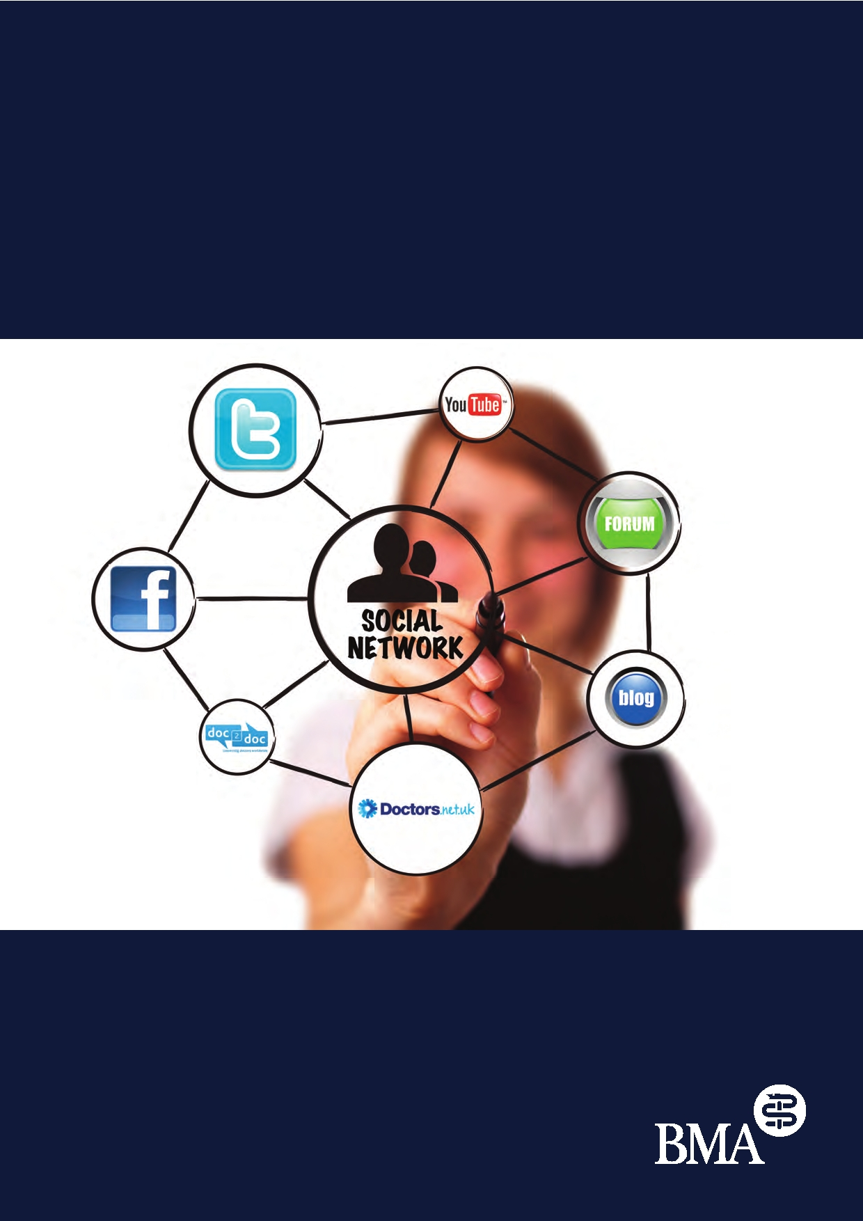
Using social media:
practical and ethical guidance for
doctors and medical students

STANDING UP FOR DOCTORS

Introduction

The popularity of social media has grown rapidly in recent years. There is widespread use of sites such
as Facebook and Twitter amongst medical students and doctors and there are a growing number of
well-established blogs and internet forums that are aimed specifically at medical professionals, such as doctors.net.uk and the BMJ's doc2doc.

While many medical professionals use social media without encountering any difficulties, media interest
and research into examples of unprofessional behaviour online have raised concerns that some doctors and medical students may be unknowingly exposing themselves to risk in the way they are using these 'web 2.0' applications and uploading personal material onto the internet.

Although medical professionals should be free to take advantage of the many personal and professional
benefits that social media can offer, it is important that they are aware of the potential risks involved.
This guidance provides practical and ethical advice on the different issues that doctors and medical students may encounter when using social media.

Key points:
• Social media can blur the boundary between an individual's public and professional lives
• Doctors and medical students should consider adopting conservative privacy settings where these
are available but be aware that not all information can be protected on the web
• The ethical and legal duty to protect patient confidentiality applies equally on the internet as to
other media
• It would be inappropriate to post informal, personal or derogatory comments about patients or
colleagues on public internet forums
• Doctors and medical students who post online have an ethical obligation to declare any conflicts
of interest
• The BMA recommends that doctors and medical students should not accept Facebook friend
requests from current or former patients
• Defamation law can apply to any comments posted on the web made in either a personal or
professional capacity
• Doctors and medical students should be conscious of their online image and how it may impact
on their professional standing

Ethical responsibilities and social media

Patient confidentiality
Social media, through blogs and web forums, can provide doctors and medical students with a space in
which they can discuss their experiences within clinical practice. As material published on the internet often
exists in the public domain however, it is important that health professionals exercise caution when
discussing any details relating to specific medical cases. Doctors and medical students have a legal and ethical
duty to protect patient confidentiality. Disclosing identifiable information about patients without consent
on blogs, medical forums or social networking sites would constitute a breach of General Medical Council
(GMC) standards and could give rise to legal complaints from patients. GMC guidance highlights that many
improper disclosures are unintentional and reminds medical professionals that they should not share
identifiable information about patients where it may be overheard, including in internet forums.1 Although
individual pieces of information may not alone breach patient confidentiality, the sum of published
information could be sufficient to identify a patient or their relatives. Doctors and medical students who
wish to publish details about specific medical cases or clinical experiences online, which identify or run
the risk of identifying a patient, should ensure they follow the guidelines relating to patient consent and disclosure set out by the GMC. The BMA also provides extensive guidance for doctors on confidentiality.2

Appropriate discussions of patients and practice
While discussion about patients and clinical experiences amongst colleagues online can have both
educational and professional benefit, informal discussion about patients on public internet forums should
be avoided. It would be particularly inappropriate for medical professionals to make personal or derogatory
comments about their patients or colleagues. Even where doctors or medical students post anonymously
and are confident that what they say will not breach patient confidentiality, they should consider how such comments will reflect on themselves as physicians or future doctors and bear in mind the potential impact they could have on the public's trust in the medical profession as a whole.

Maintaining boundaries - the doctor-patient relationship

Privacy and personal information
As the example below illustrates, social media can blur the boundary between an individual's private and
professional lives. People are often unaware that the personal material they intend to share with friends
could be accessible to a much wider audience and that once uploaded onto the web, it may not be possible to delete material or control how widely it is shared.

Public or Private?
In 2010, a civil servant complained to the Press Complaints Commission (PCC) that two newspapers
had breached her privacy by publishing updates she had posted on Twitter in a personal capacity. In the
posts, the civil servant revealed that she was "struggling with a wine-induced hangover" at work and posted a number of tweets that were political in nature. Although initially only intended to be shared with her 700 hundred followers on Twitter, publication in the national press ensured that millions read her tweets. One of the newspapers also published a picture of the civil servant that she had posted on
her Flickr page to accompany the article. The newspapers in question argued that the articles were
justified given civil service guidelines on impartiality and they had not invaded her privacy because access
to the Twitter account had not been limited to just those officially "following" her. In 2011, the PCC found in favour of the newspapers. It stated that the publically accessible nature of the information
was a key consideration in deciding whether it was private and noted that the material published
on the site related directly to the civil servant's professional life.3

Although doctors often choose to divulge personal information about themselves during face-to-face
consultations with patients, they are able to control the extent and type of this self-disclosure. The
accessibility of content on social media however raises the possibility that patients may have unrestricted
access to their doctor's personal information and this can cause problems within the doctor-patient
relationship. In an example reported in the MDU Journal, a patient treated by one of the female partners at a GP practice began sending the doctor flowers and other gifts. After the patient attempted to contact the
doctor several times on Facebook, it became clear that he had discovered information about the type of
presents she might like through the personal information that was easily accessible on her account.4

Some social media sites have privacy settings that allow users to control and put restrictions on who has
access to their personal information.5 The default settings on such sites however often permit various types of content to be shared beyond an individual's network of friends. It is important that doctors and medical students familiarise themselves with the privacy provisions for different social media applications and adjust

the settings to ensure their content is protected to the extent they would like. Research from the US suggests
that a proportion of medical professionals may not be taking advantage of these settings to limit access to
their profile, despite some accounts displaying content that could be interpreted negatively.6

The BMA recommends that doctors and medical students should consider adopting conservative privacy
settings where these are available. Not all content on the web can be protected in this way and some social
media applications do not provide flexible privacy settings. Medical professionals need to be aware of the
risks of posting content on the web which is in the public domain and be conscious at all times of who has access to their personal material online and how widely this content may be shared.

Facebook friend requests
Relationships between doctors and patients that are not based around clinical care can raise a number of significant ethical issues. Because of the power imbalance that can exist in any doctor-patient relationship, it is important that a professional boundary exists to maintain trust and protect patients from the possibility
of exploitation. It is possible, and in small communities likely, that doctors may have friends who are patients. In these circumstances, doctors and medical students should be aware of the boundaries that need to be set
and be sensitive to the need to maintain a professional relationship in the surgery or clinic. Some doctors and medical students report that current or former patients have sent them friend requests on Facebook.
While most doctors would not consider entering into an informal relationship with a patient online, research suggests that a small number of doctors have accepted friend requests from patients and that some doctors
would decide on an individual basis.7

Given the greater accessibility of personal information, entering into informal relationships with patients on
sites like Facebook can increase the likelihood of inappropriate boundary transgressions, particularly where
previously there existed only a professional relationship between a doctor and patient. Difficult ethical issues
can arise if, for example, doctors become party to information about their patients that is not disclosed as
part of a clinical consultation. The BMA recommends that doctors and medical students who receive friend
requests from current or former patients should politely refuse and explain to the patient the reasons why it would be inappropriate for them to accept the request.

Declaring conflicts of interest
US research into the content of medical blogs written by healthcare professionals found a number of cases
where authors had explicitly promoted or endorsed a specific healthcare product but had not provided
information on potential conflicts of interest.8 Doctors and medical students who post material online should be aware of their ethical obligations under GMC regulations to declare any financial or commercial interests
in healthcare organisations or pharmaceutical and biomedical companies.9 This ethical duty applies even
where doctors blog anonymously, as any material written in a professional capacity or by authors who
represent themselves as doctors are likely to be viewed by the public as such and taken on trust. Failing to declare conflicts of interests could undermine public trust, compromise the professionalism of authors and in turn risk referral to the GMC.

Medical education and employment

The erosion of the private-professional boundary can have a negative impact on the relationship between
an individual and their employer. Organisations may have access to publically available personal content
uploaded by doctors on social media and any material judged to be inappropriate could have a detrimental
impact on their professional standing. As indicated in the example below, evidence of unprofessional behaviour can also lead to disciplinary action.

In 2009, a group of doctors and nurses were suspended for taking part in the "The Lying Down Game",
an internet craze where participants take pictures of themselves lying face down in unusual places and upload them onto Facebook. The group were reported to hospital management after pictures of them
lying on resuscitation trolleys, ward floors and the ambulance helipad were spotted on the site. The
pictures broke hospital regulations and breached NHS and Trust codes of conduct. The medical director
for the trust stated that the group faced disciplinary action because they expected high standards of
behaviour from their staff and such breaches were taken very seriously.10

Medical students also need to be conscious about the image they present on social media. Guidance
published jointly by the GMC and Medical Schools Council (MSC) reminds medical students that because
they "have certain privileges and responsibilities different from those of other students...different standards of professional behaviour are expected of them."11 US research into the material posted online by medical
students, as reported by deans of medical schools responding to the study, found patient confidentiality
violations; instances of discriminatory language and profanity; and depictions of intoxication and illicit substance use, which in some cases resulted in official warnings from medical schools and dismissal.12

There are anecdotal reports that organisations are using the web to screen applicants as part of the
recruitment process. Any material on social media that shows candidates in a bad light could potentially
jeopardise job or medical school applications and damage career prospects. Doctors and medical students
should consider reviewing their content on a regular basis and remove any material they are not comfortable with displaying online.

Defamation

It is important that medical professionals are able to engage fully in debates about issues that affect their
professional lives and increasingly the internet is the forum in which this discourse takes place. The freedom
that individuals have to voice their opinions on forums and blogs however is not absolute and can be restricted by the need to prevent harm to the rights and reputations of others.

Defamation law can apply to any comments posted on the web, irrespective of whether they are made in a
personal or professional capacity. Defamation is the act of making an unjustified statement about a person or organisation that is considered to harm their reputation. If an individual makes a statement that is alleged to
be defamatory, it could result in legal action against the individual and the organisation they are representing.

People can often feel less inhibited when posting comments online and as a result may say things they would
not express in other circumstances. Posting comments under a username does not guarantee anonymity as
any comments made online can be traced back to the original author. Doctors and medical students need to
exercise sound judgement when posting online and avoid making gratuitous, unsubstantiated or unsustainable negative comments about individuals or organisations.

Professionalism and social media

Binding professional duties that doctors and medical students have to their patients are set out in GMC
guidance; breaches of these standards while using social media, such as improper disclosures of patient
information, represent clear cases of professional misconduct that can call into question the fitness to
practise of a doctor or medical student. Medical professionalism however also encompasses a broader, less well-defined set of standards that lie outside the scope of GMC regulations. These principles have evolved
with medical practice over time and, while not legally binding, they represent the standards of conduct broadly expected of health professionals by their medical peers and society. Although the way medical
professionals use social media in their private lives is a matter for their own personal judgement, doctors
and medical students should consider whether the content they upload onto the internet could compromise public confidence in the medical profession.

For further information about these guidelines, BMA members may contact:
The BMA on 0300 123 123 3 or
British Medical Association
Department of Medical Ethics, BMA House
Tavistock Square, London, WC1H 9JP
Tel: 020 7383 6286 Fax: 020 7383 6233
Email: ethics@bma.org.uk

References

1
23

4
5

6

7

8

9
10

11

12
General Medical Council (2009) Confidentiality. London: GMC, para 13.
See www.bma.org.uk/ethics
Press Complaints Commission (2011) Baskerville vs Daily Mail (2010)
http://www.pcc.org.uk/news/index.html?article=NjkzNA (accessed 22 Mar 2011).
Cuzner E. The hidden dangers of social networking. MDU Journal Vol. 25 Issue 2 (November 2009), p.13.
For information on how to change privacy settings on Facebook and Twitter for example see:
Facebook, Help Centre - Privacy, www.facebook.com/help/?page=419 (accessed 21 Mar 2011) and Twitter Help Centre, About Public and Protected Accounts support.twitter.com/entries/14016-about- public-andprotected-accounts (accessed 21 Mar 2011).
Chretien KC, Azar J, Kind T. (2011) Physicians on Twitter JAMA 305(6):566-568. Thompson LA,
Dawson K, Ferdig R, et al. (2008) The Intersection of Online Social Networking with Medical Professionalism. J Gen Intern Med 23(7): 954-7.
Moubarak G, Guiot A, Benhamou Y, et al. Facebook activity of residents and fellows and its impact on the doctor-patient relationship. J Med Ethics 2011;37: 101-104.
Lagu T, Kaufman EJ, Asch DA, et al. (2008) Content of Weblogs Written by Health Professionals. J Gen Intern Med 23(10):1642-6.
General Medical Council (2006) Good Medical Practice. London: GMC, paras 74-76.
Anon (2009) Doctors suspended after playing Facebook Lying Down Game. The Telegraph,
9 September. www.telegraph.co.uk/technology/facebook/6161853/Doctors-suspended-after-playing- Facebook-Lying-Down-Game.html (accessed 13 Feb 2011).
General Medical Council and Medical Schools Council. (2009) Medical Students: professional values and fitness to practice. London: GMC, para 3.
Chretien KC, Greysen SR, Chretien JP, et al. (2009) Online Posting of Unprofessional Content by Medical Students. JAMA 302(12):1309-1315.

