Guidance for

Completion of Form R Part B

Table of Contents

The following document details each field of the Form R giving guidance, examples and required actions. Please read through this document and ensure your Form R is correct before it is returned.

Introduction

About the Form R

Completing your Form R

- Part B
  - Forename & GMC Registered Surname
  - GMC Number
  - Primary email address
  - Deanery/LETB
  - Previous Designated body for Revalidation
  - Date of Revalidation
  - Programme/Training Specialty
  - Dual Specialty (If applicable)
  - Section 2: Whole Scope of Practice
  - Number of days TOOT (Time Out Of Training)
  - Section 3: Declarations relating to Good Medical Practice
  - Section 4: Update to previous Form R Part B
  - Section 5: New declarations since your previous Form R Part B
  - Section 6: Compliments
  - Trainee Signature

What Happens Next?

Appendix

2 Signing your Form R with a Digital Signature (detailed)

Completing your Form R

The Form R is utilised for various purposes throughout a trainee’s time with HEENW. The following guidance will take you through the form field-by-field, as well as providing technical and contextual information about what the form provides. Please read the following guidance in full before filling out your Form R.

Return of the Form R signals that the doctor has registered with the LETB for specialty training. It initiates the annual assessment process; and triggers the allocation of a National Training Number (NTN) where appropriate. All trainees will be required to complete a Form R at the beginning of their training period, and before each Annual Review of Competence Progression (ARCP).

Form R completion and acceptance is a mandatory part of every trainees training within the NHS, and the form must be accepted by the LETB within the deadline set (usually either before you begin your specialty training, or before each ARCP where applicable).

About Completing your Form R
The Form R is in PDF format and can be opened on most computers using “Adobe Reader” or “Adobe Acrobat”. Once the form is opened, you may simply type your responses to each field into the pre-defined text boxes, please ensure all of the fields with a red border are populated, otherwise your Form will be rejected as incomplete by the LETB and will need to be amended by the stated deadline. If you do not have access to these programmes, the form can be printed out and filled out by hand.

- Part B
Part B of the Form R enables a doctor’s continued revalidation to practice within the UK. This section must be filled out annually, at most 8 weeks before your ARCP. Part B includes personal
information, scope of practice statements and various declarations relating to good medical practice.

Forename & GMC Registered Surname
Action: Enter all legal Forenames and your GMC Registered Surname

GMC Number
Description: The 7 digit GMC (General Medical Council) reference number assigned when you were registered with the GMC

Primary contact email address
Action: Enter your full up to date email address

Deanery/LETB
Description: The name of the Local Education and Training Board you will be undergoing your training with
Action: This field is prepopulated with “Health Education North West”

Previous designated body for revalidation
Description: If you are joining HEENW from another LETB (Local Education and Training Board), either through recruitment to a specialty training programme or Inter Deanery Transfer, you should enter the details of your previous LETB. If you are joining HEENW from other employments (e.g. Clinical Fellow post etc.) please enter the name and details of the Medical Director/Responsible Officer of your employing organisation (including Locum Agencies).
Action: Enter the name of your previous LETB (if not applicable, leave this field blank)
Example: “Health Education East Midlands”

Date of revalidation
Description: Your current Revalidation date given to you by the GMC.
Action: Enter the date of your revalidation date – You can find your revalidation date on GMC Connect.

Programme / Training Specialty
Description: The specialty you will be training in with HEENW
Action: Select from the dropdown list of specialties the training programme you are appointed to
Example: “General Practice”

Dual Specialty (If Applicable)
Description: If entering a dual CCT training programme, this will be your primary specialty Action: Select from the dropdown list of specialties the primary specialty for the dual CCT training programme you are appointed to. If not entering a dual CCT training programme, you should leave this field blank
Example: “Cardiology” “Anaesthetics”

Section 2: Whole Scope of Practice
Description: Please indicate all placements/work that you have undertaken since your last ARCP. This includes all of your training posts; all locums, including within your own Trust; any out of programme or maternity leave; and all other work in your capacity as a
registered medical practitioner.
Action: Fill in each text box with the details of your work, select from the drop down menu for whether it was a training post (where training post is any post in which you were actively training under a LETB)
Example:

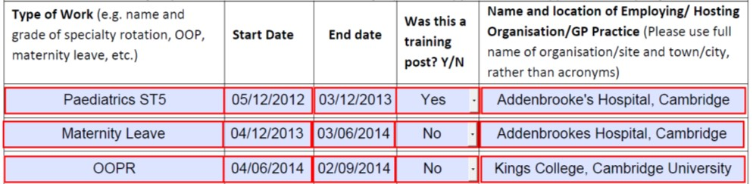

Number of Days TOOT (Time Out of Training)
Description: The GMC mandates that any trainees who have had absence from training for 14 days or more within a 12 month period must receive review at ARCP to determine whether an extension is required to the CCT date to allow the trainee to meet the training
requirements of the training programme. This doesn’t include any study leave, annual leave
or prospectively approved Out of Programme time (allowance will already have been made for this).
Action: Enter your number of days out of training since your last ARCP into the correct TOOT fields, if you have not had any TOOT please enter “0” into these fields.

Section 3: Declarations relating to Good Medical Practice
Description: These declarations relate to the Good Medical Practice Guidance issued by the GMC, for further detail into the GMCs guidelines on good medical practice please click here.

    - Declaration relating to Honesty & Integrity, more information on this declaration can be accessed via the GMC by clicking here.

    - Declaration relating to personal health, more information on this declaration can be accessed
via the GMC by clicking here. If you wish to make any declarations relating to personal health please
do so below in part 4) Health Statement.

    - If you have any GMC conditions, warnings or undertakings placed on you, you must declare them now.

    - Health Statement – If you would like to declare anything to the ARCP/RITA panel with regards to your personal health, please do so in this section.

Action: Please tick the appropriate boxes and type your health declaration into the available field.

Section 4: Update to previous Form R Part B
Description: This section is used to update us of any significant events, complaints or other investigations that have been declared on your previous Form R. New declarations should not be inputted in this section, instead put any new events since your last ARCP/RITA in Section 5.

    - The GMC state that a significant event (also known as an untoward or critical incident) is any unintended or unexpected event, which could or did lead to harm of one or more patients. This includes incidents which did not cause harm but could have done, or where the event should have been prevented.

    - Almost all doctors are involved in events every year. The crucial point is to recognise them, to discuss them with your educational supervisor, and to have a record of the event and the reflection on the learning from it in your ePortfolio. The vast majority of events are learning opportunities. As part of the revalidation framework, you have to record and reflect on “significant events” in your work and to focus on what you have learnt as a result of the events.

    - If you know of any unresolved (i.e. open) significant event investigations since your last ARCP you will need to declare these and provide a brief summary. The ARCP panel will discuss these investigations with you. Do not include any patient-identifiable data in this summary.

Action: If you did not declare any Significant Events, Complaints or Other Investigations on your previous Form R, please tick the box in Part 1) and go to Section 5. If you have any previously declared events and they have been resolved since your last ARCP, Please input the details of where reflections can be located within your ePortfolio, filling in every field where an event has been declared in Part 2). If you have any previous declared events and they remain unresolved, please provide a brief summary in Part 3). You must not use patient identifiable information on this form.

Section 5: New declarations since your previous Form R Part B
Description: This section is used to declare any new significant events, complaints or other investigations since your last ARCP/RITA panels.

    - The GMC state that a significant event (also known as an untoward or critical incident) is any unintended or unexpected event, which could or did lead to harm of one or more patients. This includes incidents which did not cause harm but could have done, or where the event should have been prevented.

    - Almost all doctors are involved in events every year. The crucial point is to recognise them, to discuss them with your educational supervisor, and to have a record of the event and the reflection on the learning from it in your ePortfolio. The vast majority of events are learning opportunities. As part of the revalidation framework, you have to record and reflect on “significant events” in your work and to focus on what you have learnt as a result of the events.

    - If you know of any unresolved (i.e. open) significant event investigations since your last ARCP you will need to declare these and provide a brief summary. The ARCP panel will discuss these investigations with you. Do not include any patient-identifiable data in this summary.
Action: If you have nothing to declare since your last ARCP, please tick the first box in Part
1) and go to Section 6. If you have been involved in any events please tick the second box in part 1). If you have ticked the second box in part 1) and they have been resolved since your last ARCP, please input the details of where reflections can be located within your ePortfolio, filling in every field where an event has been declared in .If you have any unresolved events since your last ARCP, please provide a brief summary in Part 3). You must not use patient identifiable information on this form.

Section 6: Compliments
Description: In this section you may declare any compliments you have received during your time in practice. This section is not compulsory, however declaring any compliments we are unaware of will help give us a better picture of your medical practice as a whole and can be useful for the appraisal panel.

Trainee Signature
Description: You can now sign your Form R using a digital signature. This is a signature that assigns you a unique certificate verified against your email address which can be inputted on
your computer, eliminating the need to print and sign your Form R. You may see detailed step by step guidance for signing with a digital signature in the appendix by clicking here, or on Adobes official website by clicking here. Please ensure the email address entered into the digital signature matches the address you will be sending your form from.
Action: Click into the signature field to begin signing your form.

What Happens next?

Once your Form R is completed and you’ve verified that all of your information is correct, the next step is sending the form. The Form R must be submitted electronically to your Fourteen Fish eportfolio under the compliance passport.

HEENW will then check your form to ensure everything is filled in and ready for the colleges/ARCP approval. If your form is not complete, incorrect or ineligible it will be rejected, and you will be emailed with the specific reason(s) for rejection. If your form is rejected you must submit a corrected version by the original specified deadline, which is usually either before your first placement starts at HEENW or eight weeks before each ARCP.

HEENW can now accept digital signatures on your Form R, this means that the form can be filled and sent entirely on your computer with no need to print & scan. However if you would rather fill out the form by hand it will need to be scanned once completed to send electronically.

Once your form has been accepted by HEENW as complete you will be assigned a National Training Number (NTN). The NTN is used throughout your training for various uses, such as registering with your college’s ePortfolio and identifying you as a registered trainee within HEENW. Your NTN will be sent via email to the same address the Form R is received from.

Placing a Digital Signature
Using Adobe Reader

A digital signature is a small box of text that you can place on a document to verify that you have „signed‟ the document. It does not look like a handwritten signature.

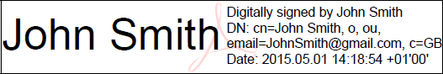Here is a picture of a digital signature. When it is placed in a document it carries hidden information which verifies who has placed the
signature and confirms that the document has not been altered.

The information on here is about placing a signature using Adobe Reader. This you can download for free from this website: http://www.adobe.com/uk/products/reader.html
It works with either Windows or Mac OSX or iOS.

Signing your Form R is the last step in completing your form, signing the form before entering all the data will invalidate the signature and your form will be rejected.

Please follow the instructions in this document so that you can apply a digital signature to your HEENW forms. Further guidance can be obtained from Adobes official website by clicking here.

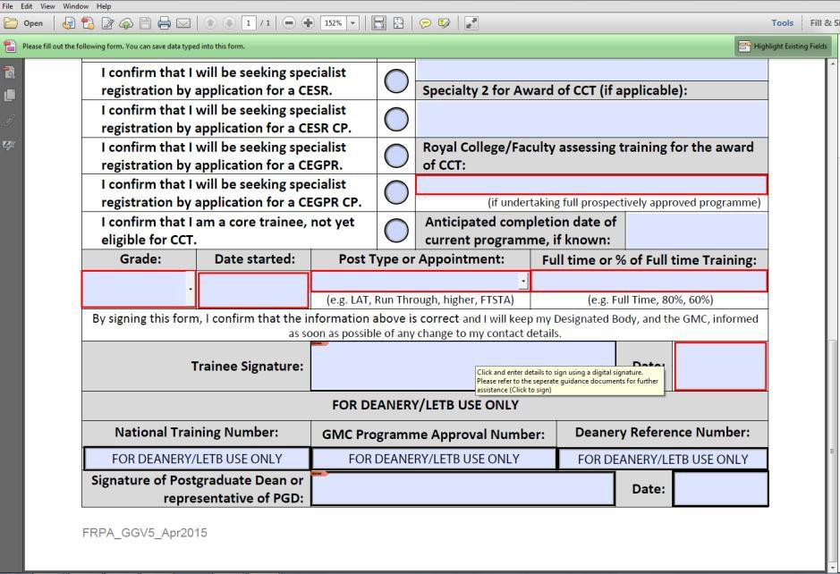Click into the signature field to begin signing the Form R

- 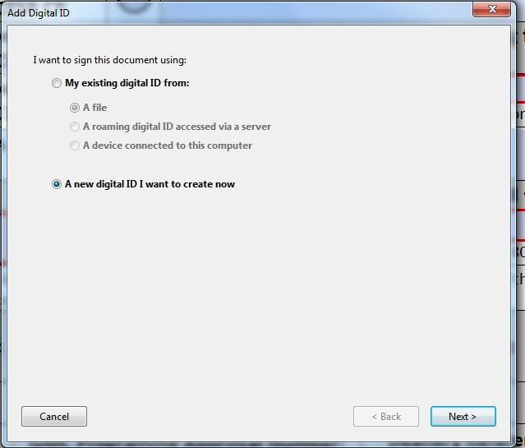This will summon the digital signature wizard, select “A new digital ID I want to create now” then click “Next”

- 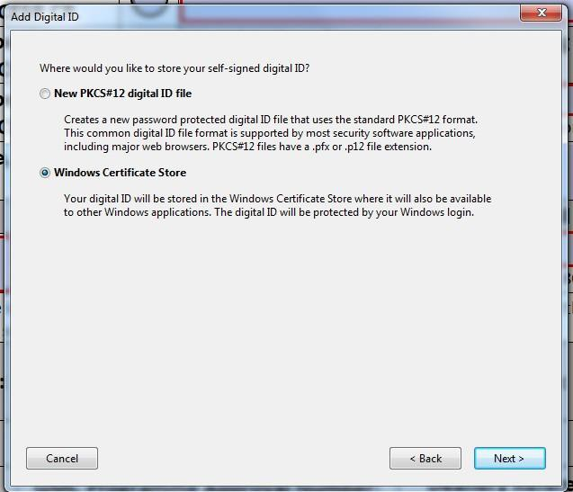Click “Windows Certificate Store” followed by “Next”

- 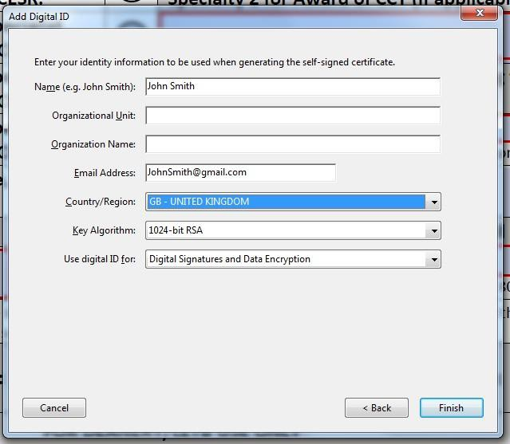Enter your full GMC registered name, email address and country, once complete click “Finish”. Please note, the email address entered here must match the address registered at HEEoE and your Form R must also be submitted to us from this same email address. If these conditions are not met your Form R will be rejected as incomplete

- 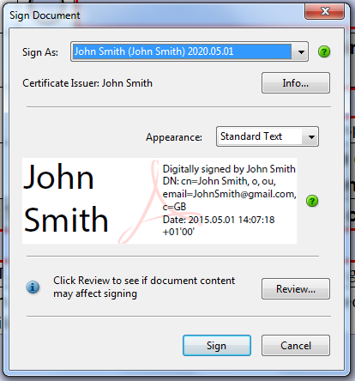You have now generated a digital signature click “Sign” to save a new signed copy

- Once saved, your digital signature will be inputted automatically into the form and it may now be submitted to your Fourteen Fish eportfolio for review

