Creating a Digital Signature Using Adobe Reader

A digital signature is a small box of text that you can place on a document to verify that you have “signed‟ the document. It does not look like a handwritten signature.

Signing your Form R is the last step in completing the form. Please be aware that signing the form before entering all the data will invalidate the signature and your form will be rejected.
Here is a picture of a digital signature. When it is placed in a document, it carries hidden information which verifies who has placed the signature and confirms that the document has not been altered.
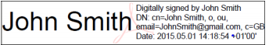
The information within this guide is about placing a signature using Adobe Reader. You can download Adobe Reader for free using this website: http://www.adobe.com/uk/products/reader.html
It works with either Windows or Mac OSX or iOS.

Please follow the instructions in this document so that you can apply a digital signature to your HEENW forms. Further guidance can be obtained from Adobe’s official website by clicking on the link: https://helpx.adobe.com/reader/11/using/sign-pdfs.html#sign_with_a_digital_id.

1. Once you have completed ALL other fields within your Form R, click into the signature field to begin signing it:
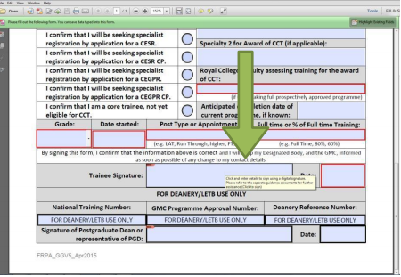

2. This will summon the digital signature wizard, select “A new digital ID I want to create now” then click “Next”
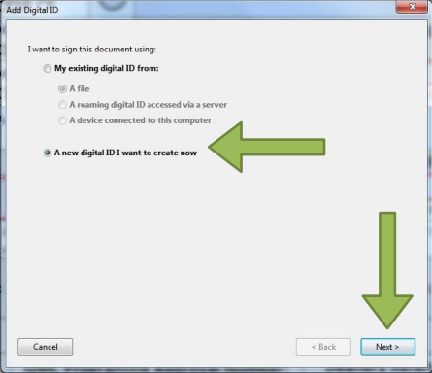

3. Click “Windows Certificate Store” followed by “Next” 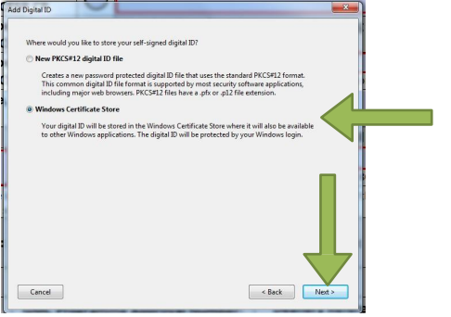

4. Enter your full GMC registered name, email address and country, once complete click “Finish”.
Please note, the email address entered here MUST match the address registered at HEENW. Your Form R must also be submitted to us or your ES as an existing trainee from this same email address. If these conditions are not met, your Form R will be rejected as incomplete. 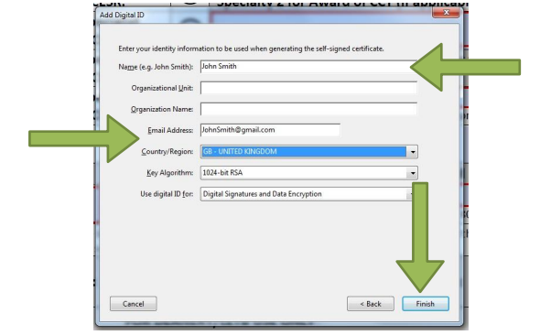

5. You have now generated a digital signature. Click “Sign” to save a new signed copy 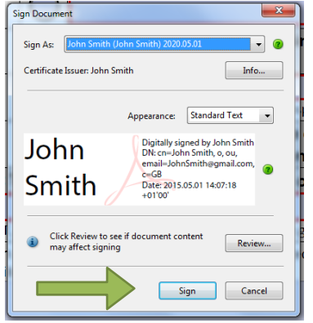

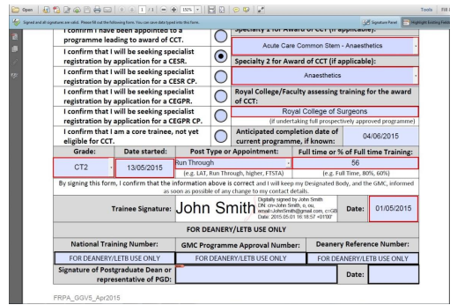
6. Once saved, your digital signature will be inputted automatically into the form and it may now be submitted.

