Checklist for Trainee/Trainer and ‘final’ ESR
Please note this only applies to Trainees due to complete training on or before 31st January 2024 and passed both CSA/RCA/SCA and AKT

All Trainees are now on ‘new’ WPBA requirements https://www.rcgp.org.uk/mrcgp-exams/wpba/asssessments

Area | Evidence required | Evidence verified
ESR | Completed within 8 weeks of the ARCP Panel  Both Trainer and Trainee signed off
Competencies/capabilities | Trainee has completed self-rating  Trainee to add 3 linked pieces of evidence to support each capability.  Trainer rated all 13 capabilities as either competent or excellent  For a satisfactory trainee who has rated himself or herself as competent for licensing in all 13 capabilities with 3 relevant pieces of tagged evidence the ES is only required to affirm the trainee evidence.
Curriculum Coverage/clinical experience groups | To complete WPBA satisfactorily by the end of ST3 all clinical experience groups should be evidenced by linkage to relevant entries in the learning logs.
Work Placed Based Assessments | Confirm minimum completed for each year of training.  LTFT the same number of assessments need to be completed per ‘training year’ e.g. a trainee on a 50% less than full time rotation will take 2 years to complete a ‘training year’  ‘New’ WPBA requirements  Trainees need to ensure evidence of leadership activity in ST3 that is separate and in addition to QIA/QIP
Learning logs | Minimum 36 clinical case reviews in ST3  1 other learning log entry per month  Evidence of reflection and learning
PDP | Minimum 1 PDP per year with evidence of completing SMART objectives.  The PDP should be a personal, reflective ‘living document’ with a mixture of open and completed entries. It should contain a mixture of entries generated personally by the trainee and from meetings with their ES.  The PDP should not only be a list of mandatory training requirements
CEPS | 1.All 5 mandatory intimate examinations assessed as competent by a suitably trained professional and documented as a CEPS assessment . Note female genitalia exam must include a speculum and bimanual  2. A range of the 7 ‘system’ CEPS observed/assessed recorded as CEPS assessments
BLS and AED | CPR and AED face to face training every calendar year, valid at CCT date that includes paeds.  Upload and attach a valid certificate of competence into the Compliance Passport  If certificate does not include paeds document confirmation in a learning log and attach to Compliance Passport
OOH/UUC | Sufficient experience and evidence across a range of settings to be able to meet the required capabilities (can be Primary and Secondary Care posts)  Must include evidence of undertaking OOH sessions  It is the responsibility of the ES to ensure that they are satisfied that these capabilities have been met by rating all 13 Capabilities as competent or excellent
Child/Adult safeguarding | Level 3 Adult and Child Safeguarding training valid at CCT  Upload and attach a valid certificate into the Compliance Passport  Plus, evidence of:  - A knowledge update every calendar year and this needs to include a demonstration of their knowledge, key safeguarding information, and the appropriate action to take if there are any concerns.  - A minimum of one Clinical Case Review in each training year which demonstrates the application of their knowledge
Last ARCP | Ensure Trainee has accepted/signed off last ARCP  If the Trainee was awarded an unsatisfactory Outcome at last ARCP please check/ensure the recommendations have been achieved?
Health and Probity Declarations | Trainee signed
Revalidation | Ensure any formal complaints, GMC, SUIs, SEAs that reach the GMC threshold are recorded on Form R.  Trainee to write a reflective log entry and confirm if resolved/unresolved?  Trainer to add a comment to this log entry again to confirm if resolved/unresolved?
Form R and COVID Self Declaration | Both are mandatory and completed via TIS:  A fully completed Form R and COVID Self Declaration completed within 8 weeks of each panel  - All posts listed and correct dates since last ARCP with no overlapping dates or gaps between dates  - Include all work as a doctor e.g. locum, voluntary, redeployment due to COVID  - Time out of training completed in days for each area and total box((1 week = 7 days, Friday 3 days)  - All sections/declarations ‘ticked’ and completed appropriately  - Declare all formal complaints, GMC, SUIs, SEAs that reach the GMC threshold  - Signed and dated  HEE Form R guidance  https://nwpgmd.nhs.uk/general-practice-education-north-western-deanery/faqs-0#_Form_R

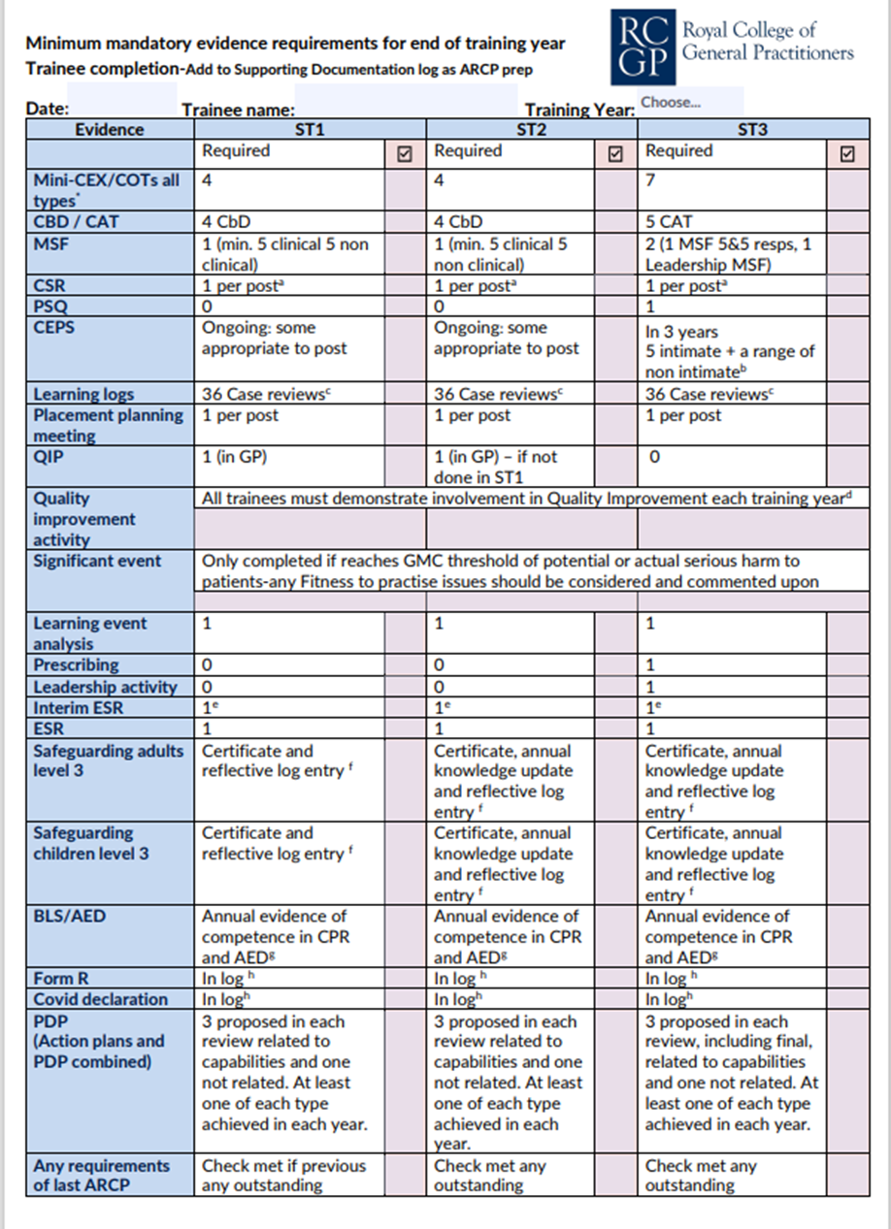

* COT of all types to be completed over the training time including audio, remote and face to face i.e. patient is in the same room as the trainee.
a CSR to be completed in a primary care post if any of the following apply: The clinical supervisor in practice is a different person from the educational supervisor. The evidence in the Portfolio does not give a full enough picture of the trainee and information in the CSR would provide this missing information, and either the trainee or supervisor feel it is appropriate.
b 5 Intimates need to be observed and include rectal, breast, female genital including bimanual, male genital and prostate A range of other non-intimate CEPS relevant to General Practice is also required.
c CCR The trainee should have more than one log entry which addresses each capability in each 6-month review period. Therefore, a range of logs should be completed, not only clinical case reviews, in order to capture capabilities such as organisation, management and leadership, ethics, and fitness to practice.
d QIA is required in every training year (QIP counts in ST1/2 when in primary care). Please see RCGP website for further details of what counts as a QIA. Please note a LEA, reflection on feedback and leadership project does not count as the mandatory QIA
e the interim ESR review can be completed at the midpoint of each year only if the trainee is progressing satisfactorily. If there are any concerns about the trainee’s performance or they have had an unsatisfactory/developmental outcome in their previous ARCP then the full ESR will be required.
f If a trainee does not have a placement within a specific training year that includes children, then it is not mandatory (but still recommended) to record and document their learning on Child safeguarding. Level 3 safeguarding cert lasts 3 years but a knowledge update is needed in addition in each year if not completing the full level 3 in that training year. Certificates should be added to Supporting Documentation and the Compliance Passport and application of knowledge recorded in CCRs.
g Hands-on BLS will be mandatory from August 2022, online BLS certificate accepted until then, ALS though lasting for 3-4 years needs to be updated annually with evidence of competence in CPR and AED. Certificates should be added to Supporting Documentation and the Compliance Passport.
h Form R and COVID declaration, if required prior to ARCP panel, should be uploaded to the Compliance Passport.
Assessments- should be spread throughout the training year with roughly half being done in each review period. Less than Full time trainees are expected to do the same total number in the full training year but pro rata in each review period dependent on their percentage of time training. See roadmaps for further details.

