

THE FOUNDATION PROGRAMME

The Foundation Team


Dr Malcolm Brown, Director of Medical Education



Dr Mayen Egbe, Foundation Programme Director

Dr Emily Feilding, Associate Foundation Programme Director

Professor Paul Baker, Academic Foundation Supervisor

Joanne Warburton, Medical Education Manager

Nashaba Ellahi, Clinical Skills Educator

Louise Kearney, Foundation Programme Administrator

Dr Mayen Egbe, Careers Lead

Why choose Bolton for Foundation Training?

The Foundation Programme in Bolton accommodates 39 FY1 and 39 FY2 doctors working within the Trust and the PCT. Of the 13 foundation tracks one is a dedicated academic track (track 6) and one a dedicated management/leadership track (track 12).

Through the Foundation Programme in Bolton, we aim to give you the knowledge and skills to help you become the best doctor you can be.

Bolton is well placed to provide Foundation training, with its reputation for excellent hospital experience and teaching. We ran pilot F2 programmes for 2 years and were amongst the first in the country to do so. Prior to that we ran the innovative General Professional Training Programme, which included the first ever SHOs in General Practice.

We are an Associate Teaching Hospital (linked to Salford Royal Hospital). Clinical students in years 3-5 are placed in most specialties and so there are some opportunities for undergraduate teaching.

The Trust is an extremely busy one, and has more emergencies than any other in the North West Region. Your jobs will be rich in clinical experience. We have an excellent reputation for medical training and junior doctor education, appraisal and support.

Separate FY1 and FY2 teaching takes place in the Education Centre on Wednesday afternoons. These sessions are protected teaching sessions and are bleep free.

Educational Supervision/Mentors

Dr Egbe will act as your Educational Supervisor for the two year programme and you will be allocated a Consultant Clinical Supervisor for each four month post.
Close supervision by the consultant or general practice trainer is essential during a four month attachment.

You will also be offered the opportunity to be allocated a mentor who will be chosen depending on your career aspirations.

What do previous foundation doctors think of Bolton?

“Overall, I feel I'm getting a superior training/learning experience compared to those at quieter hospitals.”
“I hope to return to Bolton for part of my speciality training, I'll miss the place when I leave”
“Friendly staff, good teaching, busy hospital with steep learning curve from on calls”.
“Rarely bored-it's a busy DGH with fabulous pathology mix, locals friendly, consultants approachable, generally positive feel to the place-people say hello in the mornings with a smile on their face”.

The Academic Track

As an academic trainee at Bolton you would spend a session per week with your academic educational supervisor throughout the two year track. You will be required to undertake research, publication of papers and presentations at academic meetings. Whilst attaining all the usual foundation competencies, you will be expected to acquire extra experience and expertise in academic skills. This will include some responsibilities in organisation and delivery of teaching.

Although the attachment in which most time is allocated to academic activity is in the FY2 year, you will be required to make contact with your academic supervisor as soon as possible on arrival (if not before) and to maintain contact throughout FY1. Preparatory work can begin as soon as possible to make your stay more fruitful and by FY2 you should have ample opportunity to plan, deliver and present your own project related to education and training. Submission to National and International academic meetings for presentation would be expected.

The Management/Leadership Track

Alongside the skills, competence and experience you will be gaining as a Foundation Doctor you will have the opportunity to develop your skills and competence as a leader within healthcare. You will link in with the Medical Director at Bolton Hospitals NHS Foundation Trust developing an insight and gaining experience of the role of the medical manager in a busy acute trust. You will also work with the Bolton Improving Care System (BICS) team where you will play an active role in bringing about improvements for patients and staff using ‘lean’ techniques.

You will have a unique insight as a Foundation Doctor that will bring a fresh perspective to the team. We will take an active role in your progress and will work with you to provide you with development opportunities to run alongside your formal programme of education.

Education Centre
The Education Centre/Bolton Medical Institute is a fully integrated complex for the education, training and development of all staff of Bolton Hospitals NHS Foundation Trust, General Practitioners and members of the Bolton Medical Institute.

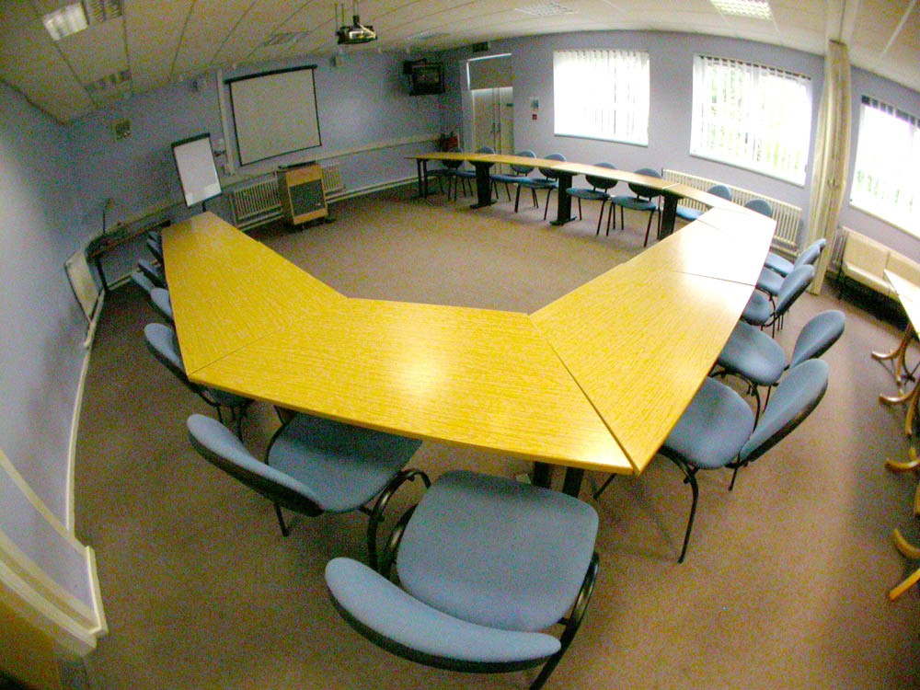

Library Facilities are available within the Education Centre. Bolton has an excellent multi-professional library with good IT facilities. The Library is accessible 24 hours a day, 7 days a week.
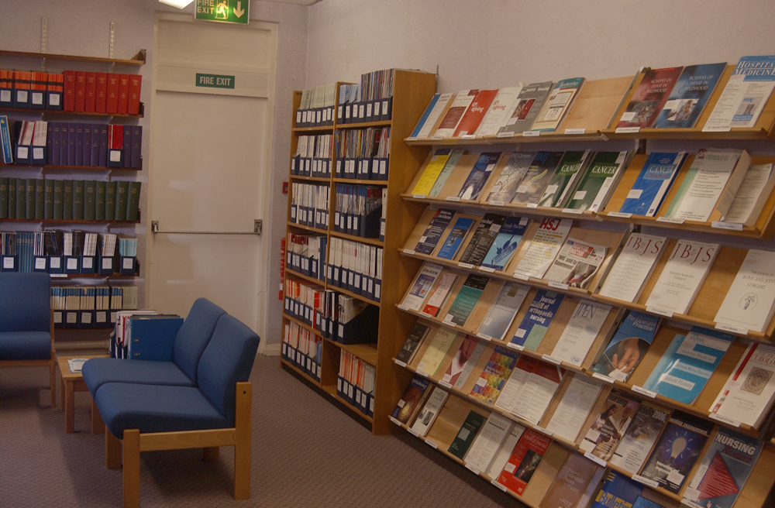

Staff Gymnasium

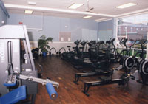

There is a staff gymnasium which is managed by staff, for staff, and this is situated at the back of D block, next to the nursery.

About the Trust

Royal Bolton Hospitals NHS Foundation Trust offers patients a wide range of services based at the Royal Bolton Hospital in Farnworth, close to the M61, as well as some which take place in community settings.

Mental health services are provided at the Royal Bolton Hospital but are managed by Greater Manchester West Mental Health NHS Foundation Trust.

Renal Dialysis is provided by Salford Royal NHS Foundation Trust.

At the heart of the Trust’s Strategy is the Trust’s Vision which is set out below:

Our Vision is to be the best hospital in the NHS. We believe that this means that by 2012 we will achieve performance in the top 10% in the country aiming for:

- Best possible care for our patients
- Improved health for our community
- Joy and pride in work for our staff
- Value for money for the taxpayer

Our strategic direction is focused on:

- Providing excellent and accessible emergency care
- Providing a range of leading planned diagnostic and treatment services
- Being a specialist women’s and children’s service
- Providing services closely integrated with primary and community services
- Being a leader in safety and quality at the most competitive cost

The Trust has developed a Bolton Improving Care System and a leadership development programme involving managers and health professionals. Using ‘Lean’ techniques it has already achieved some spectacular improvements for patients and staff.

Making it Better at the Royal Bolton Hospital
Making it Better is a £20 million investment to improve and expand services for women, children and babies.
The Royal Bolton Hospital is becoming a regional 'supercentre' for the care of women, children and babies. We are expanding and improving our facilities to create a centre of excellence in maternity, paediatric and neonatal care. Building work started in September 2009 and is due for completion before the end of 2011.

Building a better future
The Making it Better progamme will transform the care we provide and includes:
- The expansion of our central delivery suite, including new delivery rooms, a birthing pool, waiting rooms and an assessment area
- A new antenatal day unit with a new scanning department
- The expansion of our postnatal wards, including extra single ensuite rooms
- A new neonatal critical care unit where newborn babies who need extra help will be looked after
- The refurbishment of our neonatal special care unit
- A new 42 bed children's ward

Visit: www.boltonhospitals.nhs.uk for further information on the Trust.

Out and About in Bolton

Bolton is one of the UKs largest towns brimming with big ambitions, friendly people and an abundance of entertainment and sports facilities. It is within easy reach of both Manchester and Liverpool city centres and the beautiful Lake District, Peak District, West Pennines and Fylde Coast.
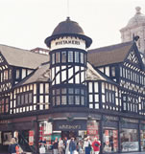
Bolton by day offers a wealth of attractions for you to visit. Wander in the surprisingly beautiful countryside or visit the many historical buildings and sites that surround the town or visit the town centre with first class shopping opportunities.


Did you know that in Bolton you can:
- Watch a live premier league football match at the Reebok Stadium, home of Bolton Wanderers FC
- Visit the 14th Century Smithills Hall, one of the oldest manor houses in the North West of England
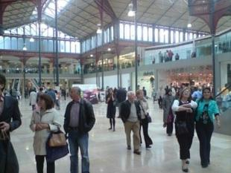
- Discover the life and times of Samuel Crompton, inventor of the spinning mule
- Watch bread being made and taste it fresh at the famous Warburton’s Bakery
- Pull on your walking boots and explore the West Pennine Moors, only 2 miles from Bolton Town Centre
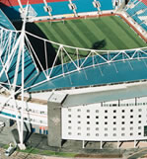
- Hear ghost stories in the town’s oldest pub, The Old Man and Scythe, which dates from the 12th century

For further information on rotations in Bolton, please contact:

Louise Kearney, Foundation Programme Administrator
Louise.Kearney@rbh.nhs.uk Tel: 01204 390427

Or

Paul Henshaw, Employee Service Centre Manager
Paul.Henshaw@rbh.nhs.uk Tel: 01204 390755

